**Individual Presentation Links**

|  |  |
| --- | --- |
| **Name** | **Links** |
| Kerryn Loo Yuxian | <https://youtu.be/nKoKxrVtVYQ> |
| Lee Feng Yuan | <https://www.youtube.com/watch?v=M9iq8yEn5QQ> |
| Ong Jing Yee | https://ntu-sg.zoom.us/rec/share/6u-i0scBb4ODSwKWH1bGBjH0SdiGlJANdM_c6qGrtapGfLYwx-IzX6yPgyB-tMn1.3QCUHJZpNMk0ohqa?startTime=1650018441000 (Passcode: p9%U=OfN) |
| Xavier Soh Jun Jie | <https://drive.google.com/file/d/1z4aIIs-Q8LYtuvGHZY2ReXfZ57-wFSTK/view?usp=sharing> |
| Yeo Galvin | <https://youtu.be/ClQS1GemynM> |



**BC3407 Programming for Business Transformation**

**Project: Minimising No-Shows in Clinics with Flask, Python**

**Seminar Group: 1**

**Team: 1**

**Instructor: Nguwi Yok Yen**

|  |  |
| --- | --- |
| **Name** | **Matriculation Number** |
| Kerryn Loo Yuxian | U1910278H |
| Lee Feng Yuan | U2011230A |
| Ong Jing Yee | U1810383H |
| Xavier Soh Jun Jie | U1910126F |
| Yeo Galvin | U2010712B |

Table of Contents

Executive Summary v

1. Introduction 1

2. Issues identified 1

2.1 Patients not showing up for appointments 1

2.2 Doctors unaware of patients’ likelihood of flaking on appointments 2

2.3 Objective of Project and Business Problem 2

3. Data Cleaning 3

3.1 Column Names Conversion 3

3.2 Data Types Conversion 3

3.3 Erroneous and Missing Data 4

3.4 Data Consistencies After Cleaning 5

3.5 Data Stratification 6

3.6 Further Cleaning 6

4. Data Exploration 7

4.1 Assumptions 14

4.1.1 Clinic Operations 14

4.1.2 Clinic Context 14

4.1.3 Number of Doctors & Doctor ID Assignment 14

4.1.4 Appointments & Appointment Times Per Day 15

5. Our Solution 16

6. Limitations 17

7. Functions and Features 19

7.1 Homepage 19

7.1.1 Patient Login 19

7.1.2 Employee Login 19

7.2 SMS Reminder 19

7.3 Patient Interface 20

7.3.1 Confirm or Reschedule Appointments 20

7.3.2 Cancel Appointments 20

7.3.3 Make New Appointments 21

7.3.4 Dashboard 21

7.3.5 Logout 21

7.4 Staff Interface 21

7.4.1 Staff homepage 21

7.4.2 Staff Dashboard 21

7.4.3 KPI 22

7.4.4 Schedule 23

7.4.5 Search 23

7.4.6 Top No Show 23

8. User Manual 24

8.1 Home Page User Manual 24

8.2 Patient User Manual 25

8.2.1 Scenario 1: No Appointment for the Next Few Days 26

8.2.2 Scenario 2: An Appointment In the Next 3-5 Days Awaiting Action 30

8.2.3 Scenario 3: No Upcoming Appointments 36

8.3 Staff User Manual 37

8.3.1 Feature 1: Dashboard 39

8.3.2 Feature 2: KPI 40

8.3.3 Feature 3: Search function 41

8.3.4 Feature 4: Schedule 42

8.3.5 Feature 5: Top No Show 43

9. Potential Future Expansion 44

9.1 Interactive Dashboard 44

9.2 Predictive Dashboard 44

9.3 Prioritisation and Waitlists 45

10. Work Distribution 46

11. References 47

# Executive Summary

One of the industries most affected by the Covid-19 pandemic is the healthcare industry. With the rapid transmission of the virus, many people are falling sick, and some may require medical attention. However, the hospitals are not able to cope due to the sudden influx in demand which has led to the mass exodus of healthcare workers. Furthermore, the increasing number of patient no-shows exacerbates the problem as these healthcare workers could have been redirected elsewhere if they had known in advance that the patient was not coming. With the demand of patients needing to see a doctor far exceeding the supply of doctors available for consultation as well as the information asymmetry between patients and medical workers, it is very important for hospitals to implement new strategies to allocate their limited resources efficiently and to minimize resource wastages.

As such, this project aims to solve the issue of information asymmetry between patients and the hospital. Some potential causes include patients not taking the initiative to cancel their appointments due to long waiting times, or the fear of being ‘scolded’ by the hospital staff for not adhering to the initial appointment date. The website would allow patients to access it on the go, at their own convenience, and would be available 24/7. In addition, SMS reminders would also be automatically sent out to patients who have an appointment within the next 5 days and will automatically be cancelled if not confirmed by the 3rd day before their appointment. This will help to bridge the information gap between hospitals and patients and allow for more effective resource planning and allocation.

For doctors, the web application aims to provide a one stop dashboard of their schedule for the day, and any relevant data and statistics about the patients that they wish to query and view. The website also helps the doctors to keep track of the no-show rates and compare it against the KPI target. The doctors can also view different graphs to see the relationship between variables and no-shows to come up with better strategies to improve KPI.

A user manual is also included to give a step-by-step tutorial on how to best use the website and aims to account for all possible scenarios that might occur when using the webpage.

Lastly, the continuity of the web application was also projected, where it can be further developed and expanded to store a larger range of data, and even have predictive and prescriptive capabilities that are able to further enhance the clinic’s ability to predict no-shows and thus, improve the scheduling and minimising wasted resources.

# 1. Introduction

The COVID-19 pandemic has shown how gaps and weaknesses in healthcare systems can have serious implications for the health, economic, and social cohesions in different parts of the world (OECD, n.d.). An unprecedented pandemic has sent the entire globe into a frenzy, with many countries having to opt for city-wide lockdowns to contain the spread and buy more time for the healthcare sector to ramp up their production and resources to tackle the increase in number of cases.

This highlights the importance in resource planning and utilisation in the healthcare industry. This is an exceptionally prevalent issue in a small country with limited resources like Singapore. As a result of the pandemic, more outpatients’ appointments are being rescheduled in fear of catching the virus if they visit the hospital (RSM, 2020). If the rescheduling or cancellation is done at the last minute, it will lead to a further strain in the already limited healthcare resources available as doctors will end up wasting their time due an underutilisation of resources available. The rescheduled appointments will then snowball to the future, causing a surge in the number of appointments that medical professionals must attend to later.

# 2. Issues identified

## 2.1 Patients not showing up for appointments

The root cause of the underutilisation of resources is due to patients not showing up for their registered appointments, which results in a negative impact on the workflow of clinics, including the productivity and efficiencies (Lacy, 2004). Studies have shown that patients who miss their appointments tend to be younger (Barron WM, 1980). In addition, no-show rates also increase with increasing waiting times between registering the appointment and the actual appointment date (Caputo et al, 2020). Longer waiting times have shown to be associated with lower satisfaction rates, which results in less reliable appointment-adhering in a vicious cycle (Bleustein et al, 2014). In addition, when patients do not show up for their appointments, there will be a delay in their treatment process, which might lead to more serious implications on their health in the future.

## 2.2 Doctors unaware of patients’ likelihood of flaking on appointments

When a patient does not show up for their registered appointment, the doctor does not know this information before, and when no rescheduling is done, the doctor might end up waiting for the patient for the entire duration of the appointment, leading to wasted time and resources that could have been used to see another more urgent patient. In the perspective of the hospital, heavy repercussions are incurred because of no-show (Pesata et al., 1999) estimated a loss of over a million dollars due to 14,000 missed appointments. No-shows have also been said to waste a quarter of scheduled time in clinics and cost them 3% to 14% of their anticipated daily revenue (Moore et al., 2001). We can see that a patient not showing up for their appointment not only impacts the patient themselves, as they would not be able to find out what is wrong with them. It will also impact the hospital and doctors in terms of wasted time and potential revenue.

## 2.3 Objective of Project and Business Problem

A patient not showing up for their appointments has significant consequences for everyone involved. Hence, this project aims to come up with a web-based application/program that aims to tackle the issue of no-show in a patient for the various stakeholders:

For patients, the website would remind them of their upcoming appointment when a patient logs onto the website using their unique identification number (patient_id). It would also allow for the patient to reschedule their appointment online when they realise that they would not be able to make it for the original date. This is a form of active rescheduling done by the patient, which is said to be more effective in tackling no-shows compared to passive rescheduling done by the clinic staff (Liu et al., 2019). No-show probability decreases by almost 11% when the appointment has been actively scheduled, which is a 4% increase than if the same appointment was rescheduled passively (Liu et al., 2019).

For doctors, the website aims to show an overall view for all the patients they have on that day, and the details (age, health, any pre-existing medical conditions) of the patients. In addition, we have also included a patient “show-up” rate based on the frequency of their no-shows compared to their shows. This hopes to give the doctors a rough gauge on how likely the patient would not show up. While it may not be possible for the doctor to see another patient during that time slot, he can perhaps plan to do other administrative work on hand. This would allow the doctor to better plan his time and resources, instead of being shocked at the patient unexpectedly not showing up.

# 3. Data Cleaning

Data wrangling and exploration were performed concurrently to ensure the accuracy of our analysis. The two processes of data wrangling carried out were to change the data type and to correct erroneous data.

## 3.1 Column Names Conversion

Other than for consistency and accuracy, as a good practice, the column names which originally had spaces were converted to one without spaces. For example, “Waiting Time” was changed into “Waiting_Time”. Variable names with spaces are considered bad practice due to the potential errors that will be faced. With the variable names having a space leading to difficulty in coding, it will also make codes difficult to understand and become non-transferrable. (Mastros, 2009)

## 3.2 Data Types Conversion

Data types in programming serve an important purpose. It is important to convert data to the types it should be to make full use of it and allow more insightful analysis. For example, if a numerical variable is a string, some mathematical functions cannot be used on it such as mean and median. Therefore, the data types are changed where necessary in the dataset.

Specifically, these are the converted data types:

1. Register and Appointment Dates are changed to pandas datetime format.
2. “YYYY-MM” format was also derived from these 2 variables for analysis on seasonal trends instead of analysing it by date.

With these converted data types, it will provide more meaningful insights for data exploration and visualisation even for the end-users.

## 3.3 Erroneous and Missing Data

While attempting to explore the data concurrently, some erroneous data were found, and further cleaning was done to improve the analysis of the data.

|  |  |  |
| --- | --- | --- |
| **Issues** | **Instances Found** | **Cleaning/Actions Done** |
| Duplicated Data | 343 Complete Duplicates | Removed |
| Age | 6 Instances of negative age | Negative age removed |
| Handicap | 499 Instances of Value Mismatch (2,3,4) with Documentation (0 or 1) | 2,3,4 replaced with 1 |

With these erroneous data removed and replaced from the dataset, it will provide for better exploration and analysis and thereafter a more accurate and efficient program to be developed.

## 

Some other data were also required to prove the efficacy of the prototype which were missing:

1. **Patient/Doctor Login Information**

With the lack of patient IDs and doctor IDs, there were no other means of identification for these parties.

For patients, IDs were assigned according to their health characteristics and habits, age, gender. After grouping using these parameters, it was found that over the 2 years span of the data, some patients had thousands of appointments making it unrealistic. Therefore, patients were further grouped by appointment day and waiting time under an assumption that will be discussed in the following assumption section.

For doctors, 3 Doctors were assigned to 30 patients each per day in running order from “160590” onwards to ensure that it does not clash with patient IDs.

A copy of all IDs was used as passwords for all accounts for this prototype.

1. **Appointment Time**

Time for appointment in the dataset was all set to 0000Hrs. To provide for better analysis, appointment times were assigned according to 20-minute intervals per appointment throughout the clinic’s opening hours.

1. **Appointment Status**

Appointment statuses, “Awaiting Action”, “Confirmed”, “Cancelled”, were added on an additional column for the prototype and for more useful information by the staff end-user. All past data and future data more than 5 days were assigned “Awaiting Action” due to the lack of this system while all future data within the next 3 to 5 days were assigned “Confirmed”.

1. **Appointment Number**

Appointment Number has also been assigned according to the index of the dataset and thereafter, this new column will be used as the appointment number and identification for the prototype.

With these missing data supplemented to the dataset, the prototype would be more realistic and relatable for the end-users.

## 3.4 Data Consistencies After Cleaning

To ensure that the data is consistent after cleaning, the Registration Dates have been split from Date and Time format to two separate columns - ‘Date’ and ‘Time’. This ensures that both time series data in the dataset are consistent with each other.

### 

## 3.5 Data Stratification

Other than for the uses of data exploration, since the output programme is a prototype, the large dataset will be further stratified after exploration for the purposes of proof-of-concept.

The dataset was cut down to a maximum of 90 appointments per day.

The dataset was also stratified into approximately a 70-30 split based on the appointment dates. Approximately 70% of the data will be the past data used for the program while 30% of the data will be used as future appointments. Some variables were also dropped from the future data such as whether the patient will show up as it would not have been able to be foreseeable.

After stratification, due to the dates in the dataset, the hypothetical date set will be 1 day before the start of the future data’s appointments - 24th May 2015.

## 3.6 Further Cleaning

After stratifying the data, some additional data cleaning must be done for the future data to make sense.

1. **Drop “Show Up” and “Waiting Time” Columns**

The “Show Up” and “Waiting time” columns were dropped as it would have been uncertain that the patient would show up during the appointment and whether these appointments would be cancelled or changed. Therefore, it does not make sense for the columns to be part of the future dataset.

1. **Change all Registration Dates beyond “Today’s” Date to “Today’s” Date**

There were at least 12,400 records with registration dates that were beyond the hypothetical date. This would affect the effectiveness and realism of the prototype and thus has been changed to the hypothetical today’s date, which is 24 May 2015.

1. **SMS Reminder**

As part of the solutions, all “SMS reminders” for future data have been assigned ‘Yes’.

# 4. Data Exploration

Data exploration was performed on the cleaned dataset. As the objective of our project is to minimise no-show rates, each variable was plotted against show up rates to discover trends.

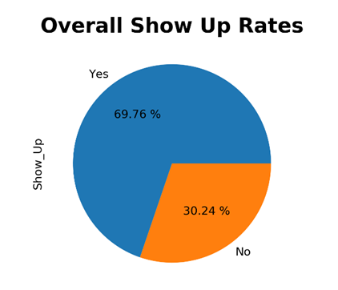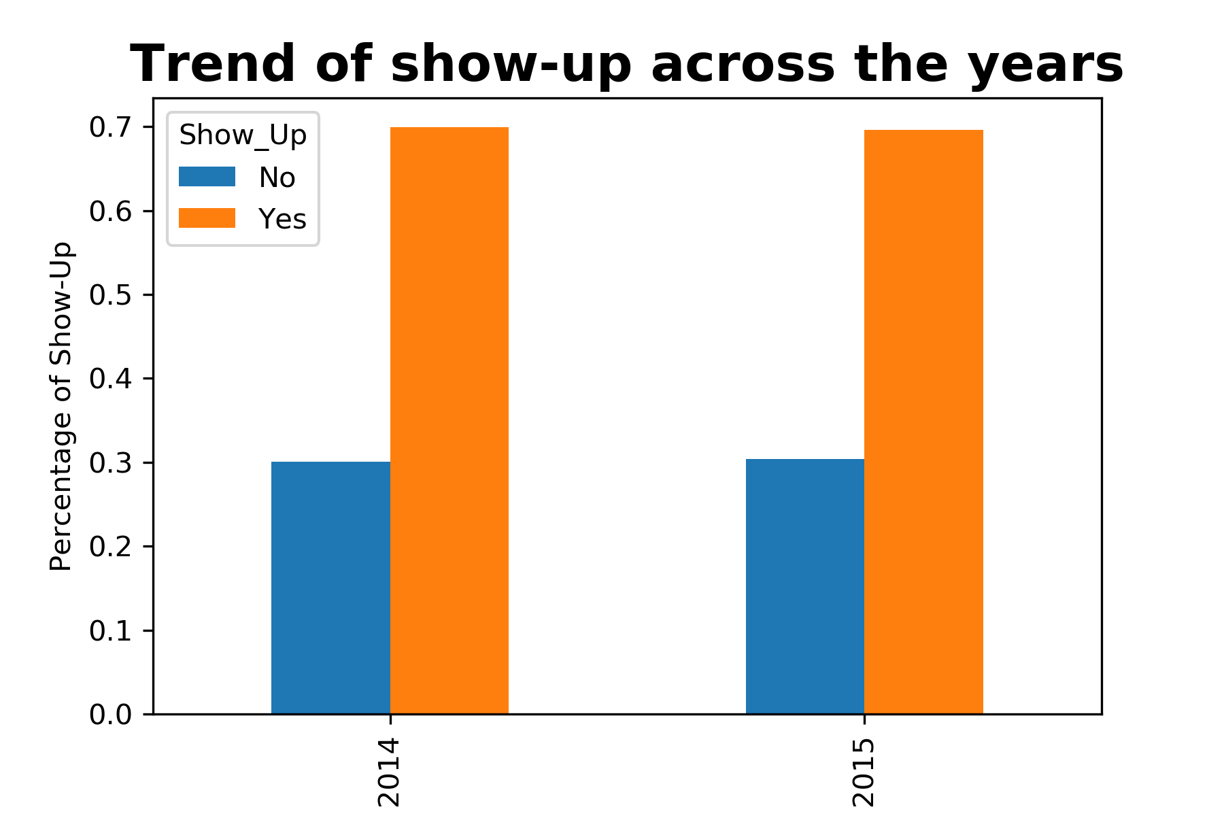

The overall no-show rate was 30.24%. The percentage of no-show rate followed a similar trend from 2014 to 2015, hovering around 30%. According to Well, the United States’ national average of patients’ no-show rate is around 18% (Well, 2022). The hospital should aim to reduce the no-show rate to the industry standard of around 18% or lower.

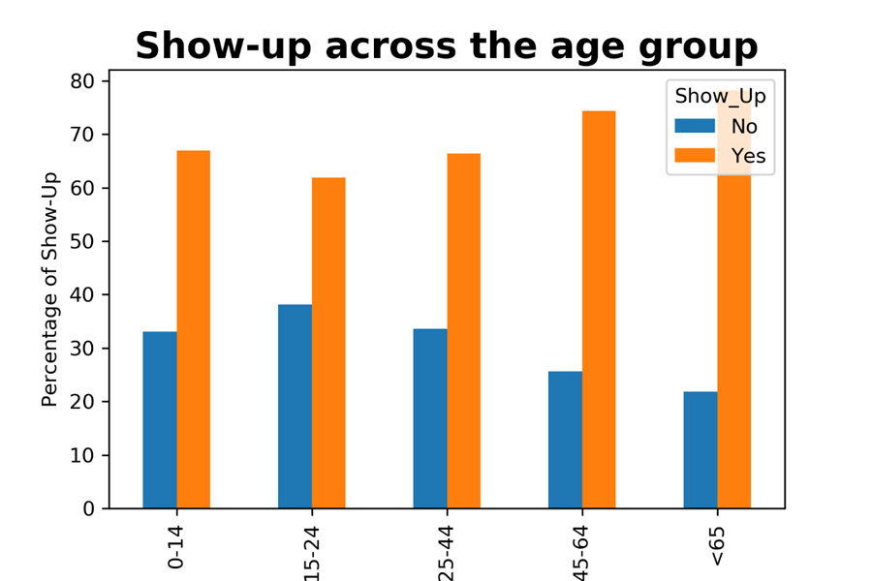 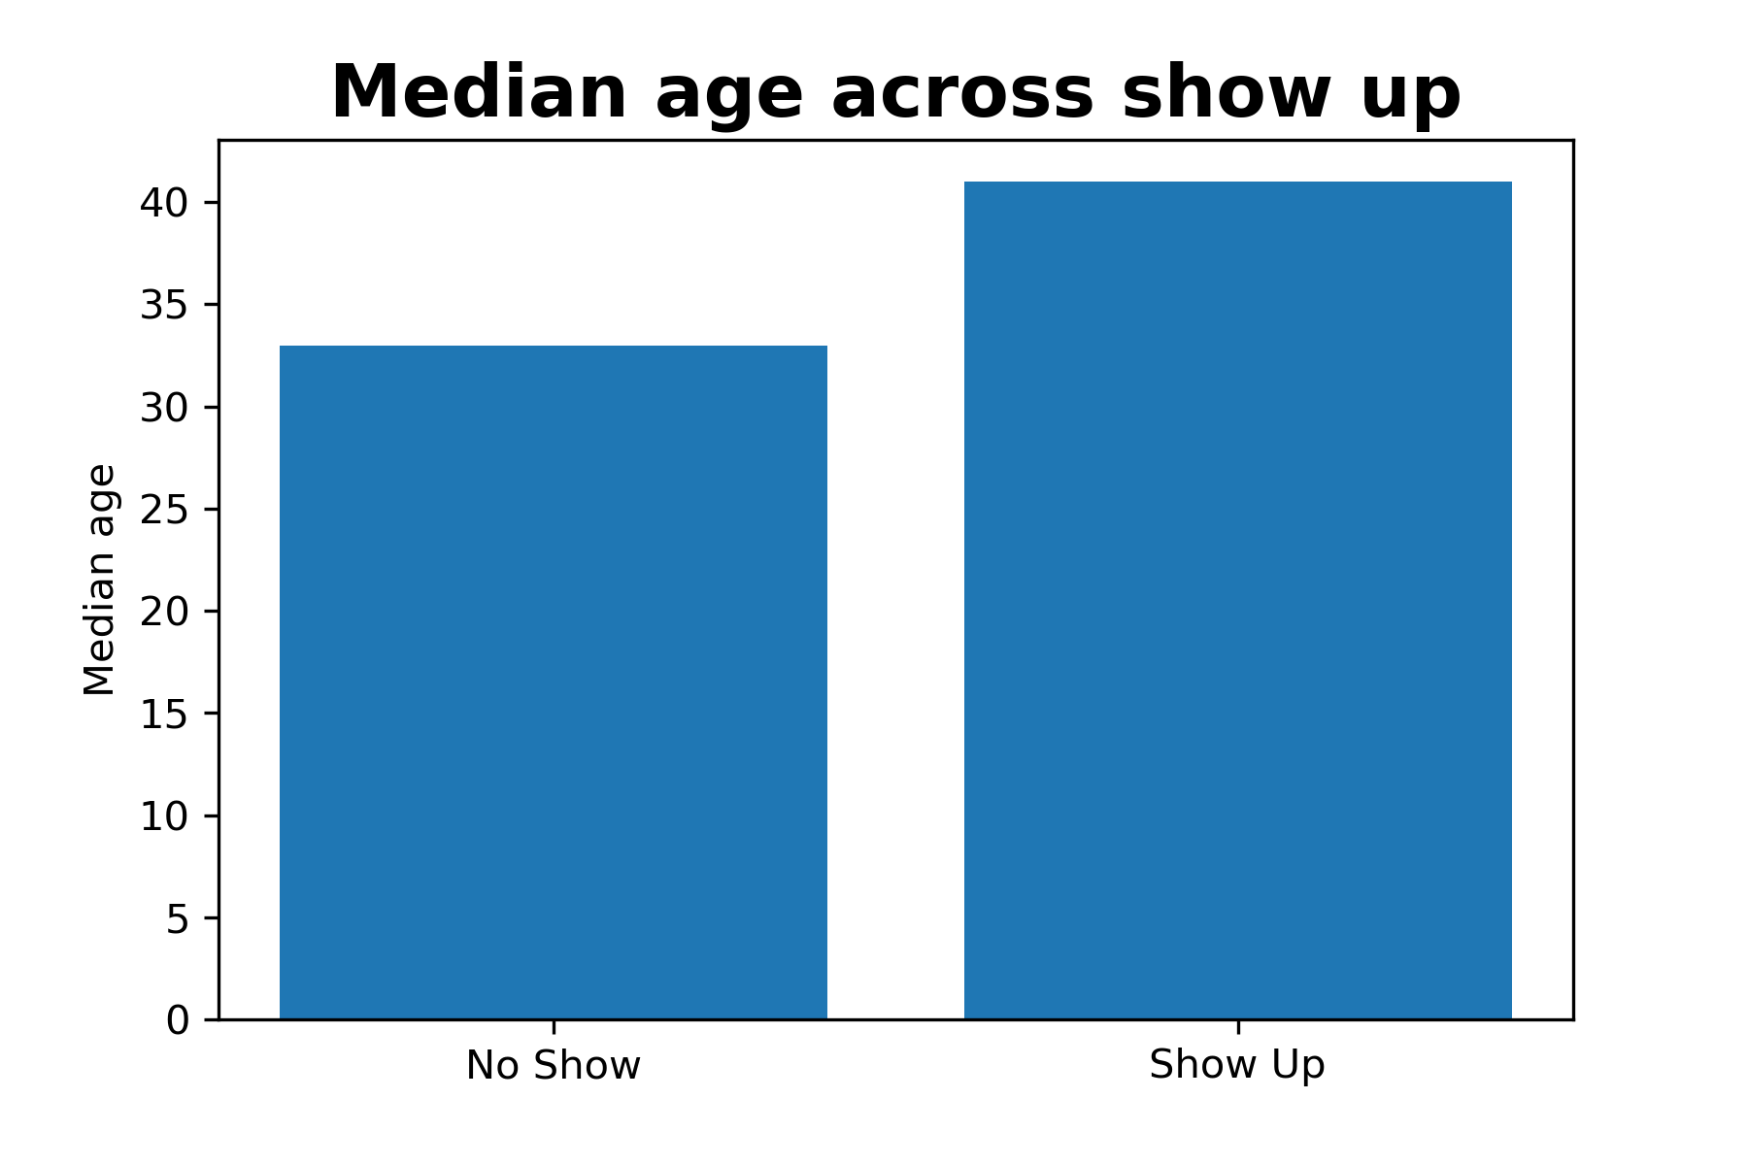

Age is classified into 5 broad categories, youth, young adulthood, middle adulthood, older adulthood, and seniors (UN, 1982). The youth category, aged 15-24, had the highest no-show rate of 38%. Older age groups, older adulthood and seniors had lower no-show rates compared to other groups. The seniors had the lowest no-show rate of 22%. This can also be seen from the median age across show-up. The median age for show up is 41, whereas median age for no-show is 33.

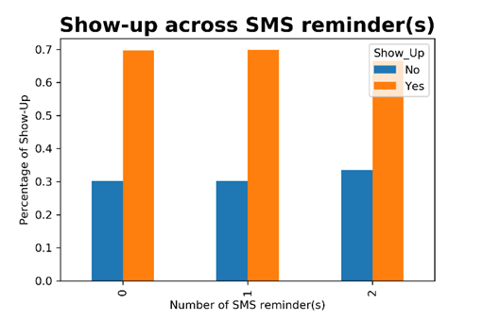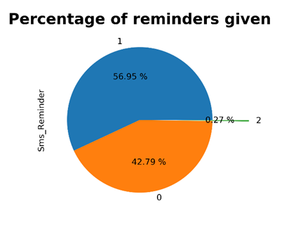

Reminder does not increase show-up rate based on the data. The patients who received one reminder had similar no-show rates as those with no reminders given. The patients who received two reminders had a higher no-show rate compared to no reminder or one reminder. However, the patients who received 2 reminders only formed 0.27% of the entire data and hence may not be too conclusive.

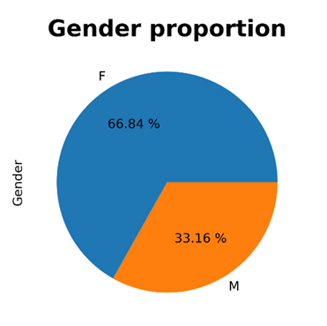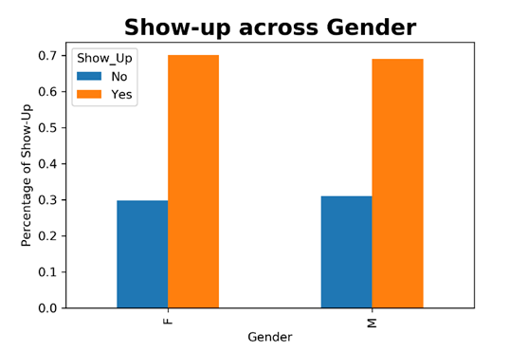

Twice the number of females made appointments as compared to males. The proportion of no-show rates among male and females were similar. No significant relationship between gender and show-up rate.

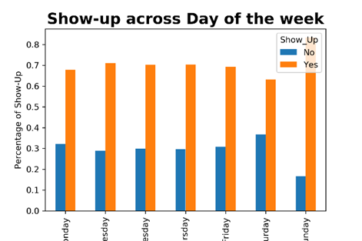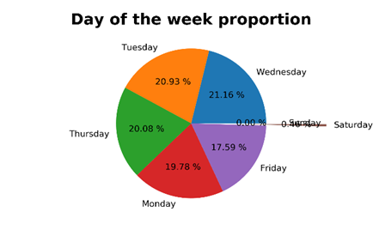

No significant trend between day of the week and show up was identified. Saturday and Sunday are abnormalities but both days only accounted for less than 0.5% of the entire dataset.

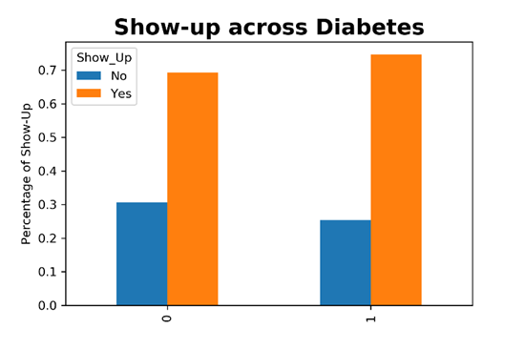

Patients who suffered from Diabetes had approximately 5% more show-up rate compared to patients who do not.

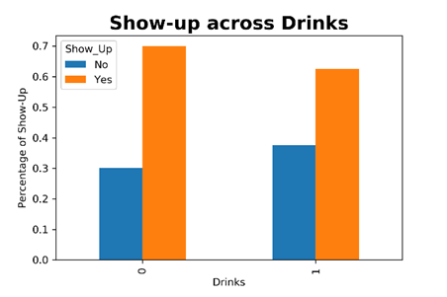

Patients who drink had an approximately 7% higher no-show rate compared to those who do not drink.

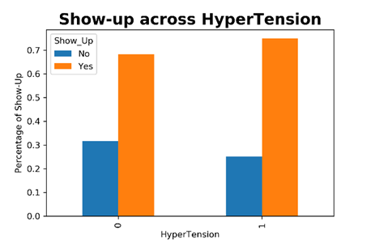

Patients who suffered from hypertension had roughly 6% more show-up rate compared to patients who did not.

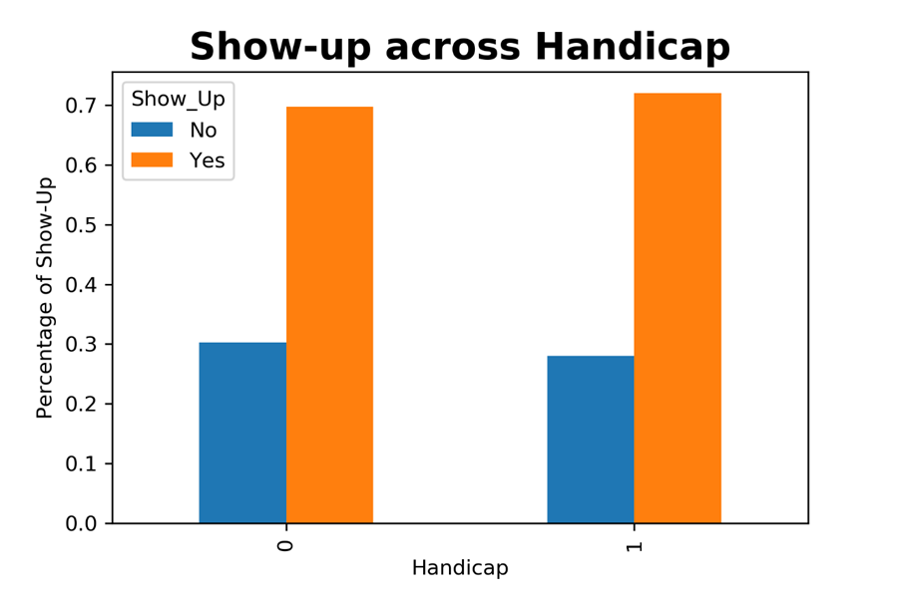

Patients who are handicapped had similar no-show rates as those who are not handicap.

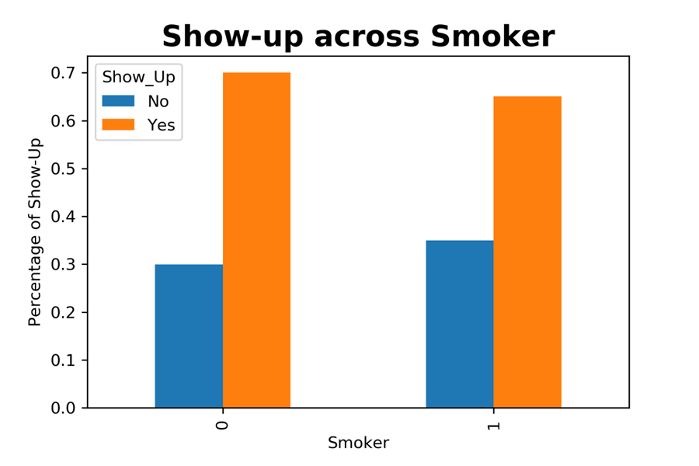

Patients who smoke had approximately 5% higher no-show rate compared to those who do not smoke.

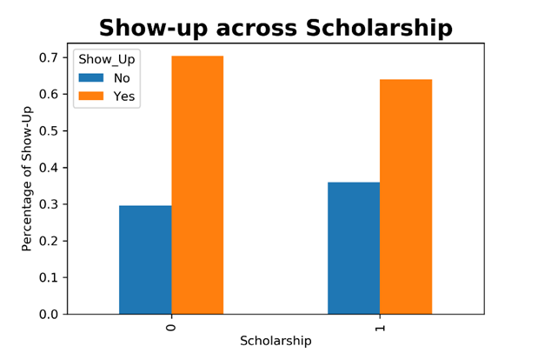

Patients with scholarships had a roughly 6% higher no-show rate compared to those without scholarship.

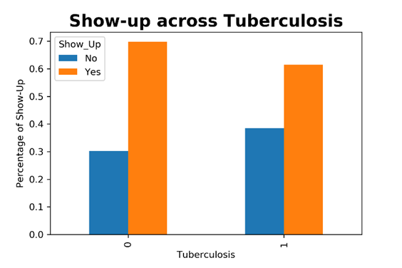

Patients who suffered from tuberculosis had roughly 8% higher no-show rate compared to those who did not have the disease.

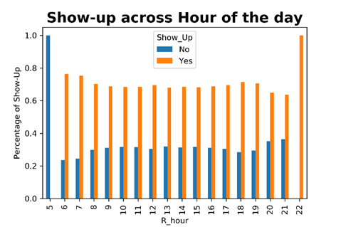

No significant trend spotted. Hours 5, 20, 21 and 22 had little data to support their trend. Patients who booked before 7 had a higher show up rate compared to other hours.

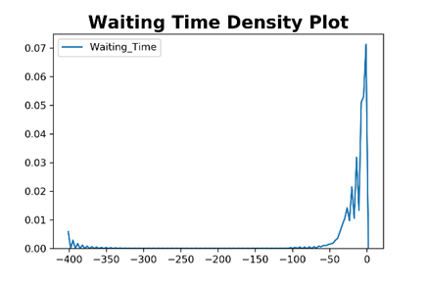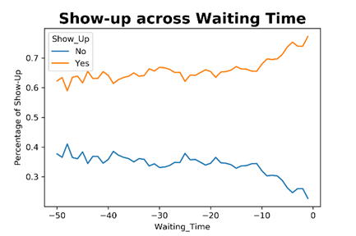

Most patients made their appointment 50 days before the appointment date as shown in the density plot. The line chart showed the relationship between waiting time of below 50 days and the show-up rate. Patients who booked their appointment closer to the appointment date had a lower no-show rate.

## 4.1 Assumptions

Some assumptions were made for the above exploration, cleaning, and prototype due to the lack of information on the dataset and context.

### 4.1.1 Clinic Operations

Firstly, to develop the prototype for the clinic, some assumptions were made about the operations of the clinic where some of which were used to develop the synthetic data in the dataset.

### 4.1.2 Clinic Context

Subject in this case is a specialist clinic, SinkHelth, inspired by but unrelated to SingHealth. It was assumed that this SinkHelth Clinic operates from 8am to 8pm, with a break of 2 hours per day from 12pm – 1pm and 6pm – 7pm. There were a few exceptions for appointments made on Saturdays and Sundays.

### 4.1.3 Number of Doctors & Doctor ID Assignment

Given that it is a small specialist clinic, there are 3 doctors that will distribute their workload evenly based on the number of patients they see per day.

For new appointments, doctors will be assigned in running order. Capacity Management would require further algorithms to be developed beyond this prototype.

### 4.1.4 Appointments & Appointment Times Per Day

With the aforementioned 12-hour operation with 3 doctors and a 2-hours break, as well as an additional assumption of 20 minutes per appointment, each doctor will have 30 patients per day.

All appointments date and times for new appointments and rescheduling is based on days and time slots where there are other existing appointments. To include time slots where there are no existing appointments, an appointment time slots dataset must be prepared which was not prepared in this case. For example, all appointment dates, time slots and vacancies of these time slots.

#### 4.1.4.1 Patient Demographics

**Patient Identification**

An assumption was made about the patients in order to generate the patients ID. Patients were generated according to their demographics and habits but required further grouping due to the unrealism of some patients having thousands of appointments in a 2-year span. Therefore, the patients were also grouped and assigned an ID based on their appointment day and waiting time which assumes that the same patient will live by the same lifestyle and routine.

#### 4.1.4.2 Prototype Implementation

**Server For SMS Prototype**

The following prototype will supplement the current SMS Reminder Service. Therefore, the SMS reminder service was developed to demonstrate how patients will be routed to the web-based application. This SMS reminder assumes that a server is constantly running to send SMS reminders at a fixed time.

**Today’s Date**

For the patient’s interface, “Today’s Date” is assumed to be 24th May 2015 due to the dataset’s date range and stratification of data for the prototype. 24th May 2015 is 1 day before the next appointment on the “future appointments” dataset. For the doctor’s interface, “Today’s Date” will be assumed to be on 25th May 2015 as it is the first day where the clinic will have actual patients.

# 5. Our Solution

Our program aims to tackle the two issues identified earlier which are:

1. Patients not showing up for their registered appointments, and
2. Doctors are not aware whether the patient will flake on their registered appointment.

For the first problem of patients not showing up for their registered appointments, we have adopted a two-pronged approach to reduce this which are:

1. To set up a confirmation system which requires patients to confirm their attendance 5 days before their appointment which also acts as a reminder, and
2. Create a one-stop platform which allows patients to make, cancel or reschedule appointments remotely and without fuss.

Firstly, for the confirmation system, patients are required to confirm their attendance via the clinic’s website 5 days before their actual appointment. This system makes patients take ownership of their upcoming appointment. As previously discussed, patients would be more inclined to come for their appointment if it was done through active rescheduling beforehand by themselves. Additionally, this also serves as a reminder for patients who may have booked the appointment some time back and forgot about it.

Secondly, this website allows patients to make, cancel and reschedule appointments which can be accessed remotely and conveniently. This convenience offered can help alleviate situations where patients know that they might not be able to make it for the appointment but do not contact the clinic as they are afraid of being reprimanded for the last-minute cancellation, or if the hotline for the clinic is engaged. Long waiting times to get through to the clinic may cause patients to baulk on their appointments when it could have been rescheduled using a webpage. Thus, with this two-pronged system, patients that might have potentially forgotten about their appointment can now take ownership of their attendance, as well as providing them with the means to change their appointment on their own without fear of being “judged” and waiting too long for the clinic staff to change it for them.

For the second problem of doctors being unaware of whether the patient will flake on their registered appointments, our program helps doctors to have an overview of his or her patients for the day and the attendance rate of these patients displayed in the day’s schedule. With this, doctors can have a rough sense about which patients may be unlikely to show up and thus, they can move on to do other administrative work if the patient does not show up in the first 5 minutes. This helps to alleviate the situation whereby the doctor is unsure if the patient will show up and end up doing nothing for the entire 20-minute time slot.

Additionally, a dashboard feature was implemented whereby doctors and nurses can monitor the variables that affect no shows as well as their KPI which measures the number of shows in three periods: this month, this year and to date. By identifying important variables that influence no show rates, the clinic can implement targeted strategies to prioritise these patients in booking appointments as well as manual rescheduling to suit their schedules. Some examples include encouraging patients to book closer to the date rather than too far in advance since no show rate increases with waiting time as well as implementing additional reminders to patients that are younger since they tend to show up less. The KPI system allows doctors to check if they have achieved the clinic’s targeted KPI. This helps to motivate the doctors to keep up their good work or to perform better to achieve the targeted KPI.

Moving forward, they may want to analyse the variables that cause significant variation to KPI in between months so that they can perform targeted strategies at these groups of people.

# 6. Limitations

Although this solution attempts to address the issues identified earlier as much as possible, there are still certain limitations faced.

One of the limitations is the need for the user to be tech-savvy. As this solution positions itself as an online one-stop solution, the user needs to be able to use the internet and we have tried to simplify the steps as much as possible. However, given the ageing population in Singapore, some of the clinic’s customers may not be tech-savvy enough to use the website and enjoy the benefits it brings.

Thus, to mitigate this problem, the clinic still must maintain their hotline system in which the nurse or receptionist can assist patients to do the necessary amendments to their appointments. Additionally, it may be wise for the clinic to do a filtering based on age before auto-cancelling the appointments as mentioned earlier in our appointment function since these patients did not choose to not confirm their appointments but rather, were unable to do so as they are not tech-savvy.

Another limitation that faced is data limitations. As most of the data is derived from a fictional dataset, the variables that influence no-shows are largely the same across the dataset as to present a balanced viewpoint which may not reflect the true realirty. Additionally, when building a subset of patients for program testing, a strict requirement of needing a 5-day gap between Appointment Dates and Registration Dates was enforced as part of the assumptions. As a significant proportion of the original dataset have waiting time lesser than 5 days, the diagrams and graphs generated to show influential factors that affect no show may not be grounded in reality and when this is applied to an actual clinic that requires booking more than 5 days in advance, the variables that affect no shows may differ significantly from what was visualised based on the dataset itself.

Therefore, clinics should take the insights generated earlier with a pinch of salt and use actual clinical data to supplement this fictional dataset before zooming in on insights and implementing strategies to tackle a non-existent problem. Additionally, there may be more important variables that affect no show rate besides the patient’s conditions and are not currently captured in the dataset. One example would be weather conditions as it has been identified in literature reviews to be an important factor in predicting no shows (Marbouh et al, 2020)

# 7. Functions and Features

## 7.1 Homepage

The main function of a homepage is to direct users around our site. The homepage provides links to navigate through our site such as patient login as well as employee login page. The homepage also allows users to navigate to partner sites by clicking on the icons of the various health agencies in Singapore. It also provides news or updates that users might be keen on having a short read as well as display the functions as well as potential future functions. The homepage is also equipped with an image slider to display the most up to date information, announcements, and news.

### 7.1.1 Patient Login

The patient login page allows current patients to login using their ID and password. This will direct them to their patient interface to set or reschedule appointments.

### 7.1.2 Employee Login

The employee login page is solely for employees to login using their ID and password. This will direct them to the employee interface to manage appointments and view the overall activities of colleagues.

## 7.2 SMS Reminder

Using an example of a simple SMS reminder system by Callr (Berdah, 2018), we will create a proof of concept in which the clinic can adapt based on the actual requirements for their use. Assuming that they can get an API to do simple SMS like Callr, our program will get the list of patients that are due for appointment in 5 days' time, and extract out information such as Patient_ID, Appointment Date and Timing to craft a message. As this dataset is a mock dataset, there are no names and phone numbers, but in actual usage, the clinic can then add these variables to the dataset. From there, we will use Python’s loop function to generate a list of variables to send to the API so that it can be sent to the patients. The message to send to the patient is as follows:

*“Dear Mr/Ms {Name}, You have a consultation at Sinkhelth on {AppointmentDate} at {AppointmentTime}. To view or reschedule your appointments, logon to our website at {websiteName}.com.”*

The purpose of this SMS is to redirect the patients to the clinic’s webpage so that they can perform the required operations to confirm or cancel the upcoming appointment

Moving forward, additional work may be needed to capture status codes returned by the API to signify success or failure to send the message. This may be due to data issues such as incorrect phone number or human error which needs to be manually inspected by staff.

## 7.3 Patient Interface

Upon logging in from the Homepage, patients will have access to a few features that they can use in the patient section of the webpage. They will be able to see their upcoming appointments at a glance. The features on the patient section varies according to their upcoming appointments.

### 7.3.1 Confirm or Reschedule Appointments

If the patient has been led from the SMS reminder 5 days before their appointment, they will have one of the following actions for their upcoming appointment.

Firstly, patients can confirm or reschedule their upcoming appointments only if the status of their appointment is “Awaiting Action” and is within the next 5 days. Upon rescheduling of the appointments, a doctor who has no appointments in that slot will automatically be assigned in running order of doctor IDs.

### 7.3.2 Cancel Appointments

Next, patients who decide that they are unable to make it for the appointment can cancel their appointments within the 3- to 5-day window or even beyond that. However, if no action is completed by the 3rd day before the appointment, the appointment will automatically be cancelled. Once the appointment is cancelled, it will no longer be displayed in the homepage. It will be retained in the database for recording purposes.

Cancellation, Confirmation and Rescheduling will be irreversible and will be updated in real-time on the patient’s homepage of their appointments.

### 7.3.3 Make New Appointments

If the patient does not have any appointments, the patient would be encouraged to book a new appointment. Otherwise, any patient can also book a new appointment, in which the doctor will be assigned to the patient similar to rescheduling.

### 7.3.4 Dashboard

This page gives an overview of the patient’s past appointment records, including those that they have missed. In addition, the page also serves to let the patient know their no-show rate versus that of the overall hospital no-show rate. If the no-show rate of the patient is lower than the overall rate, it means that the patient has been showing up to their registered appointments and thus contributing to the overall productivity and efficiency of the hospital, while at the same time keeping their health in check. They would be encouraged to keep up the good work of showing up for their appointments.

However, if the no-show rate of the patient is higher than the overall hospital rate, the patient would then be encouraged to reschedule their future appointments in order to avoid having a bad credit rating.

Lastly, the dashboard shows a graphical representation of the patient’s no-show rate versus the overall hospital no-show rate.

### 7.3.5 Logout

When patients are done with the system, they can log out of the system which will lead them back to the login page.

## 7.4 Staff Interface

### 7.4.1 Staff homepage

Upon logging in from the staff log in page, the staff will be redirected to the homepage to select and use the feature.

### 7.4.2 Staff Dashboard

One of the features provided to the staff is to view different dashboards. The dashboards are different variables plotted against no-show rates. The purpose of the dashboard is to allow staff to make strategic decisions after knowing the relationship between the variable and no-show rate. The dashboards are mainly split into two categories, namely categorical variables such as diseases or gender plotted against no-show and continuous variables such as waiting time and age plotted against no-show.

Possible strategies to reduce no-show for categorical variables will be the groups that are more likely to show up will have a higher priority in booking appointments or these groups can be contacted if someone reschedules their appointment.

Strategies for continuous variables can be more targeted. For waiting time, the staff can understand that patients who booked closer to the appointment date are less likely to cancel. Hence, the clinic can encourage patients to book closer to their appointment date instead of booking it way in advance. For age, we can see that people who are older are more likely to show up. Hence, the clinic can consider giving priority to patients that are older.

### 7.4.3 KPI

The other feature provided to the staff is to check the key performance indicators (KPI). KPI allows business to assess its performance and aids the business to achieve its objectives. One of the objectives of the clinic is to reduce no-show rates. The average no-show rate in the United States is 18%, as benchmark, the clinic can set a KPI to keep no-show rate below 20%.

The target KPI of below 20% is clearly displayed at the top of the page to remind the staff to work towards it. The staff can read the current KPI of the month below the chart. The monthly KPI is either in green or red font. If the clinic manages to hit the KPI, the website will display the current KPI in green and they are encouraged to keep up their good work. If the clinic failed to achieve their KPI, the website will display the current KPI in green and they will be reminded to work harder.

The staff can proceed to look at the bottom of the KPI page to see a comparison between monthly, yearly and till date KPI. This comparison will help them assess how well they are doing now compared to before. As the KPI is constantly tracked, staff will ensure that they take necessary steps to improve their current KPI.

### 7.4.4 Schedule

In the schedule, the patients for the specific doctor are displayed and sorted according to appointment time. This is coupled along with the status of the appointment as well as the attendance rate of the specific patient so that doctors can have a rough sensing on whether the patient is likely to be late or is a no-show patient if he/she is not here within the first 5 minutes of the appointment. The patient id displayed here can also be used to search for their medical history as well as their appointment records.

### 7.4.5 Search

In the search function, staff who have identified certain patients they want to know more about, can enter the patient ID into the search box and it will return the relevant patient’s medical history, attendance rate as well as past & future appointments. This is to consolidate all relevant history of the patient into one source so that doctors can see an overview at one glance.

### 7.4.6 Top No Show

In the top no show function, the staff can choose to filter based on a threshold of no shows as well as the number of patients they want to see. For example, a nurse may be interested to find out which patients contributed significantly to the no show rates and thus, they would be able to filter out these patients based on their needs.

# 8. User Manual



**SinkHelth Web-Application User Manual**

**Updated 15 April 2022**

Developed & Prepared By BC3407_G1

## 8.1 Home Page User Manual

In the homepage, users can select from the homepage, new appointment, patient login or employee login. Depending on the users if they are a patient or employee, they will have to select their respective login page. The new appointment page will redirect the user to the patient login page. Homepage will redirect users to the main landing page.

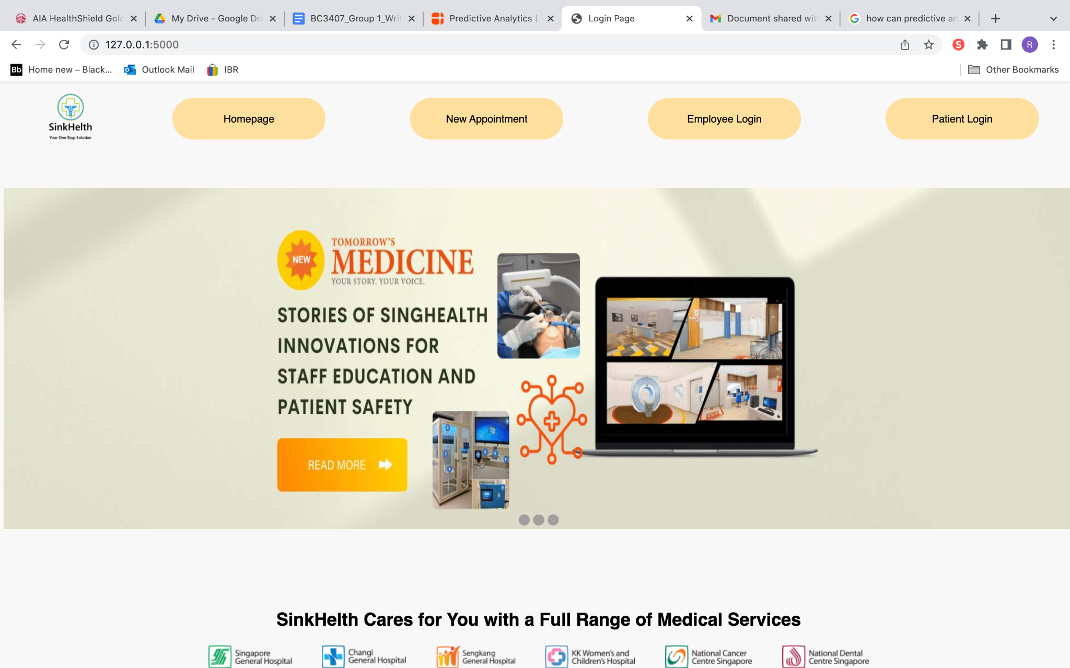

## 8.2 Patient User Manual

After selecting “Patient Log In” from the homepage, the patient will be led to the login page as follows. For demonstration purposes, Patient ID: 9301, Password:9301was used to login.

Login Page

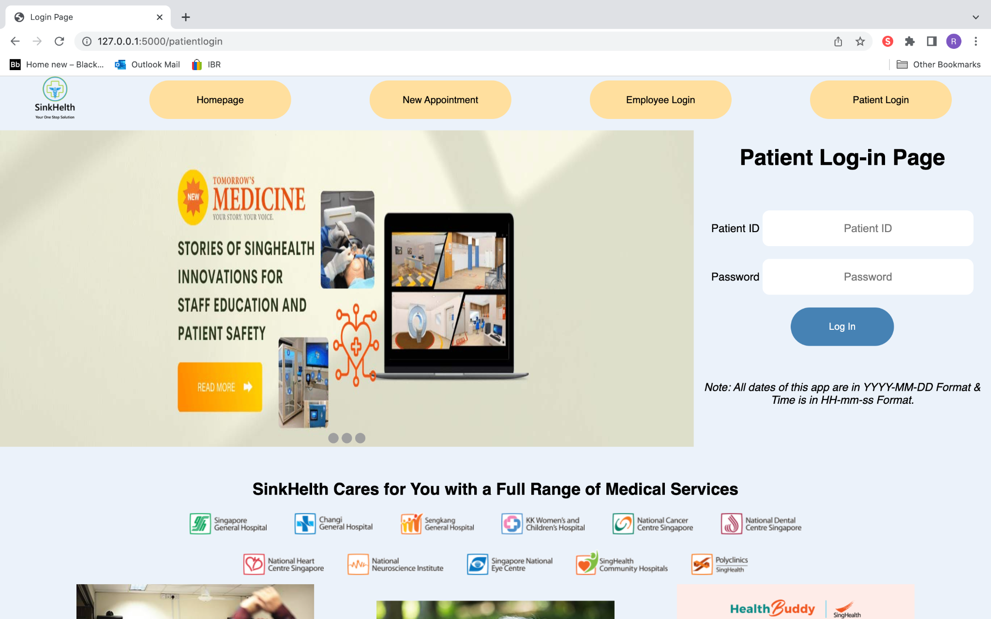

Click Log In

Key Assigned Credentials

After the user enters in their patient ID and password which has been set by the clinic, the patient can click the ‘Log In’ button or press “Enter” or “Return” on their keyboard.

In the case where the patient did not key in anything for either of the fields or if the user ID or password keyed in does not match the stored ID and password of the patient, an error message will be shown and the input fields will be cleared, prompting the user to try again.

### 

Upon logging in with the correct credentials, the patient will be led to the patient’s homepage which may vary according to the patient’s upcoming appointments.

However, all pages during this session with the patient logged in will have a toolbar at the top of the page where the user can navigate around the patient’s pages.



### 8.2.1 Scenario 1: No Appointment for the Next Few Days

When no actions are required for the patients, patients can either visit their dashboard, cancel their appointments, make a new appointment, or simply view their upcoming appointments.

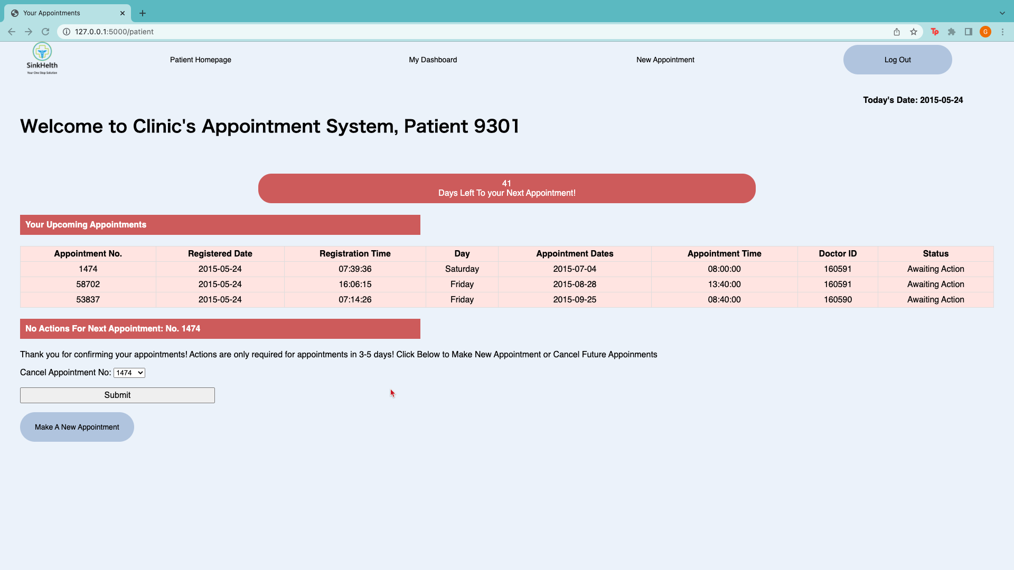

Date For All Pages with Date Information

Welcome Message with Patient ID

Reminder of Days to Next Appointment

Upcoming Appointment Details and Status

#### 8.2.1.1 Step 1.1a: Cancel Appointment

Since no further action is required, patients can only cancel or reschedule their appointments in the future.

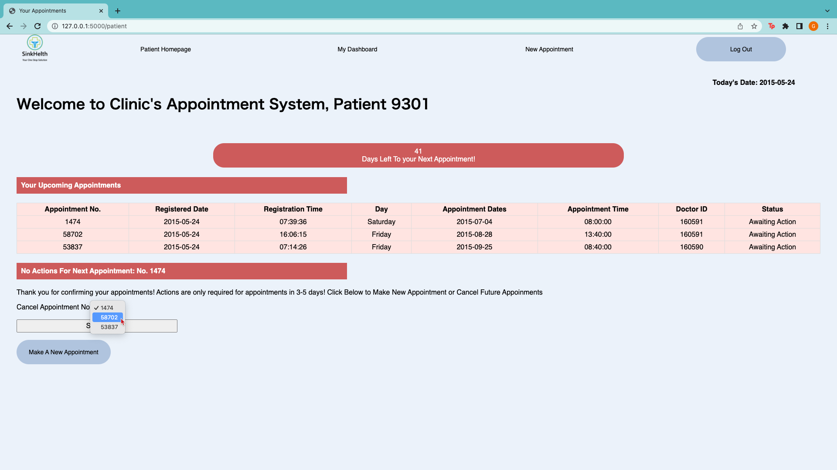

Submit to Cancel Instantly

Select Appointment to Cancel from Dropdown List

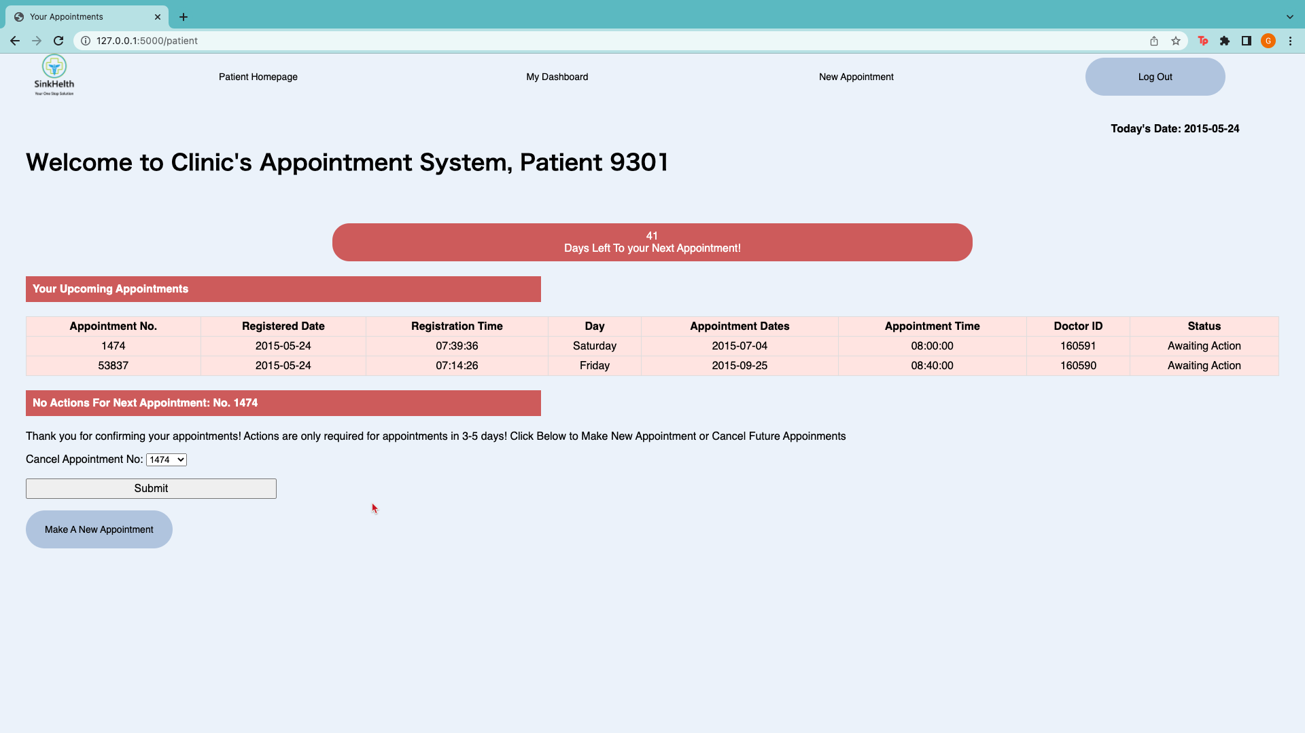

Appointment Cancelled and Removed From DisplayAppointment cancelled and removed from Display

Click to make New Appointment

#### 8.2.1.2 Step 1.1b: New Appointment

Patients may also make appointments for the future using this portal. A workaround for rescheduling can be done by patients by making a new appointment then cancelling the unwanted one.

Patients can click on either the “New Appointment” at the navigation bar or below their upcoming appointments if they do not have any actions required where they will be led to the new appointments page below. In this page, a list of available time slots after the 5th day will be displayed according to the clinic and doctors’ capacity, and patients can click “Schedule Appointment” to make a new appointment. Thereafter, patients will be led to the Main Page and changes can be seen from the image below.

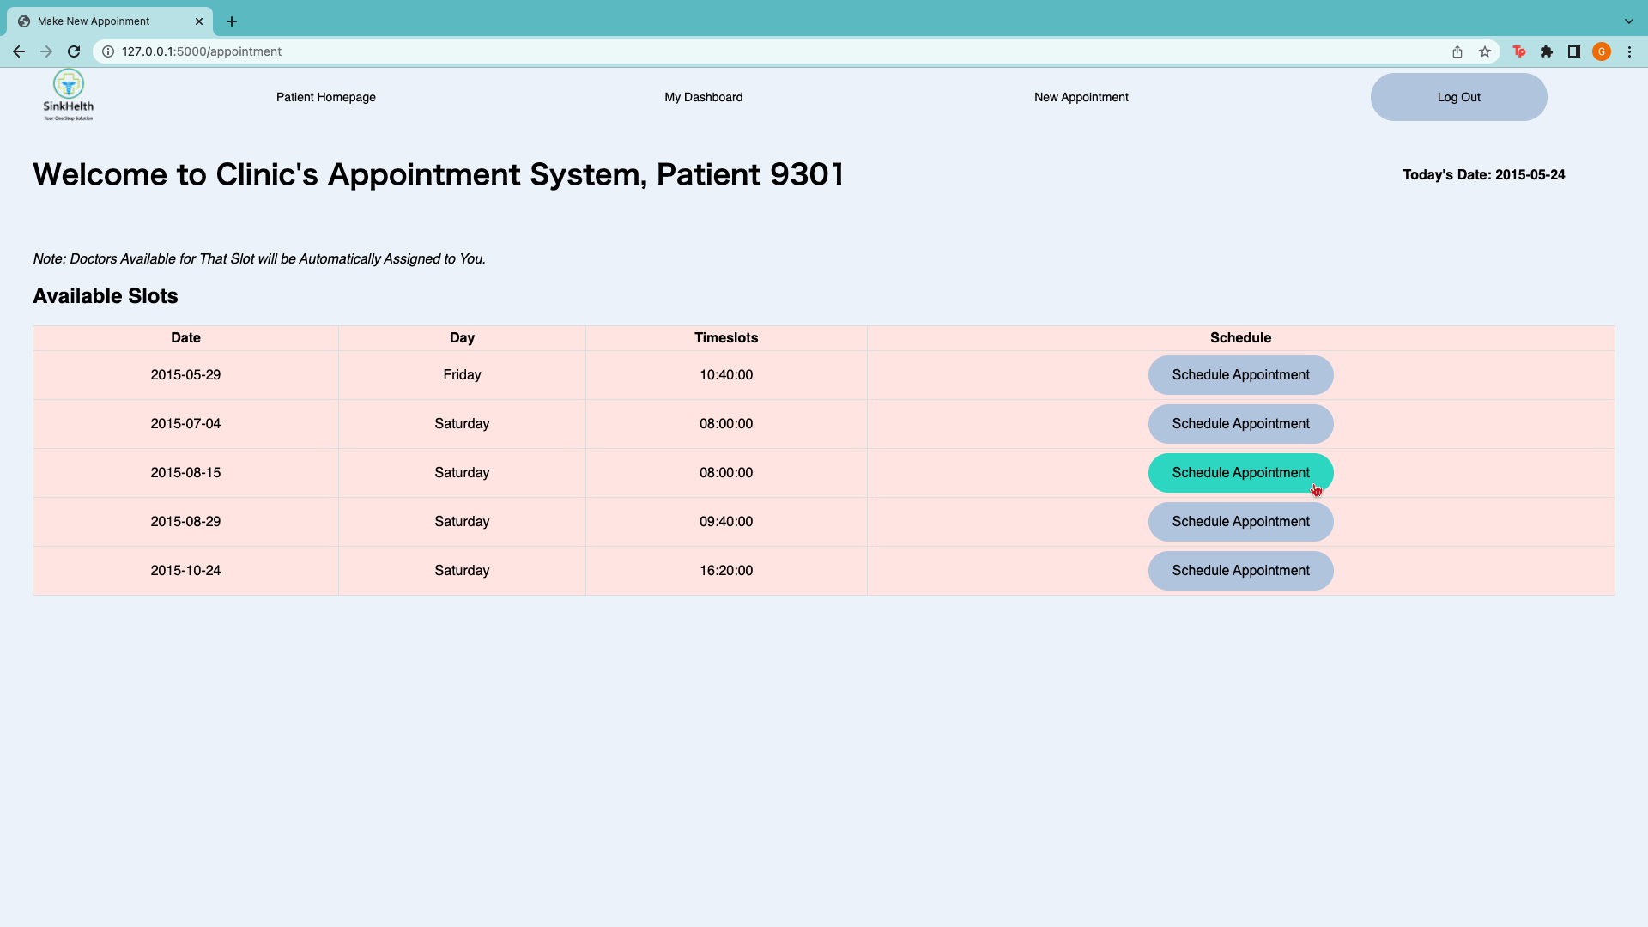

Appointment Information

*Note: Doctors Will Automatically Be Assigned Based on Availability*

Click to Schedule Appointment

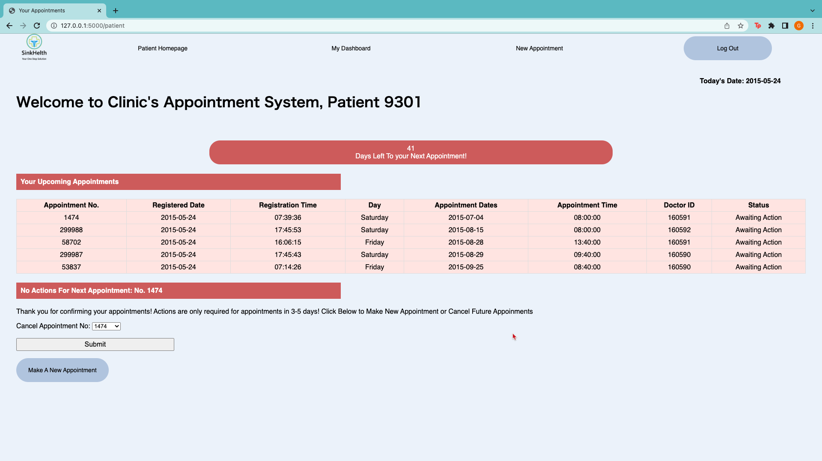

Doctors Assigned Based on Availability

New Appointment Updated

#### 8.2.1.3 Step 1.1c: View ‘My Dashboard’

Additionally, patients can view their dashboard by clicking on the “My Dashboard” button on the toolbar where they will be led to the following page.

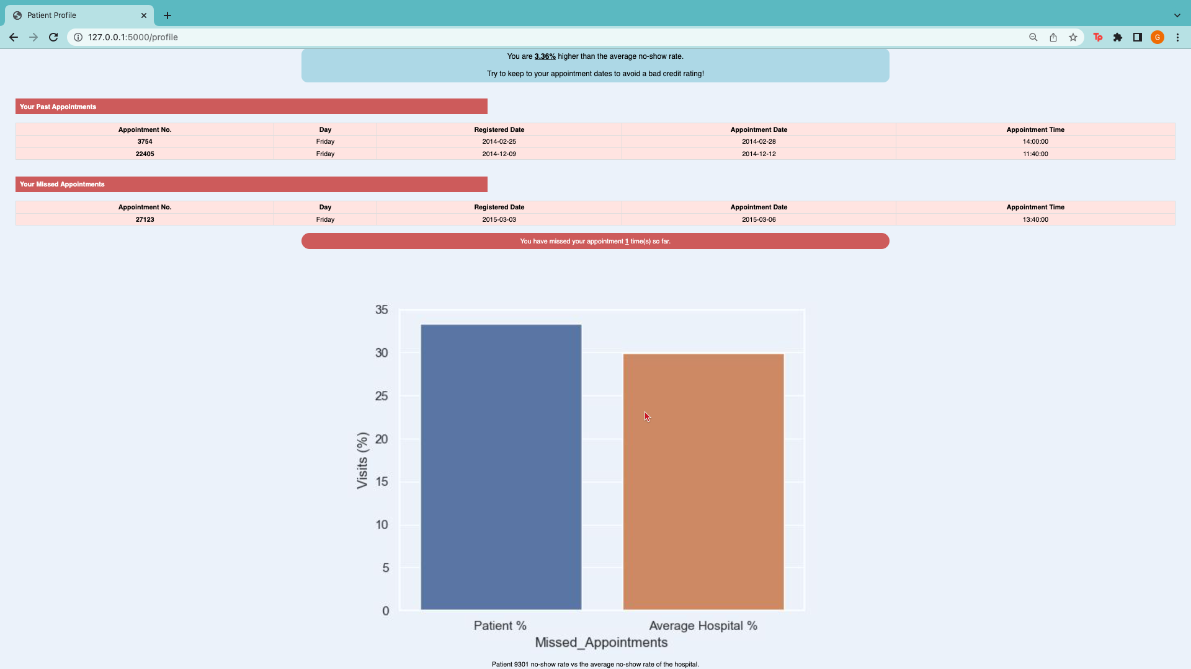­

This page shows the patient how many appointments they have missed, how they are doing as compared to other patients, and information on their past and missed appointments. A visualisation is also shown on how often they have missed their visits relative to the average hospital missed visits.

### 8.2.2 Scenario 2: An Appointment In the Next 3-5 Days Awaiting Action

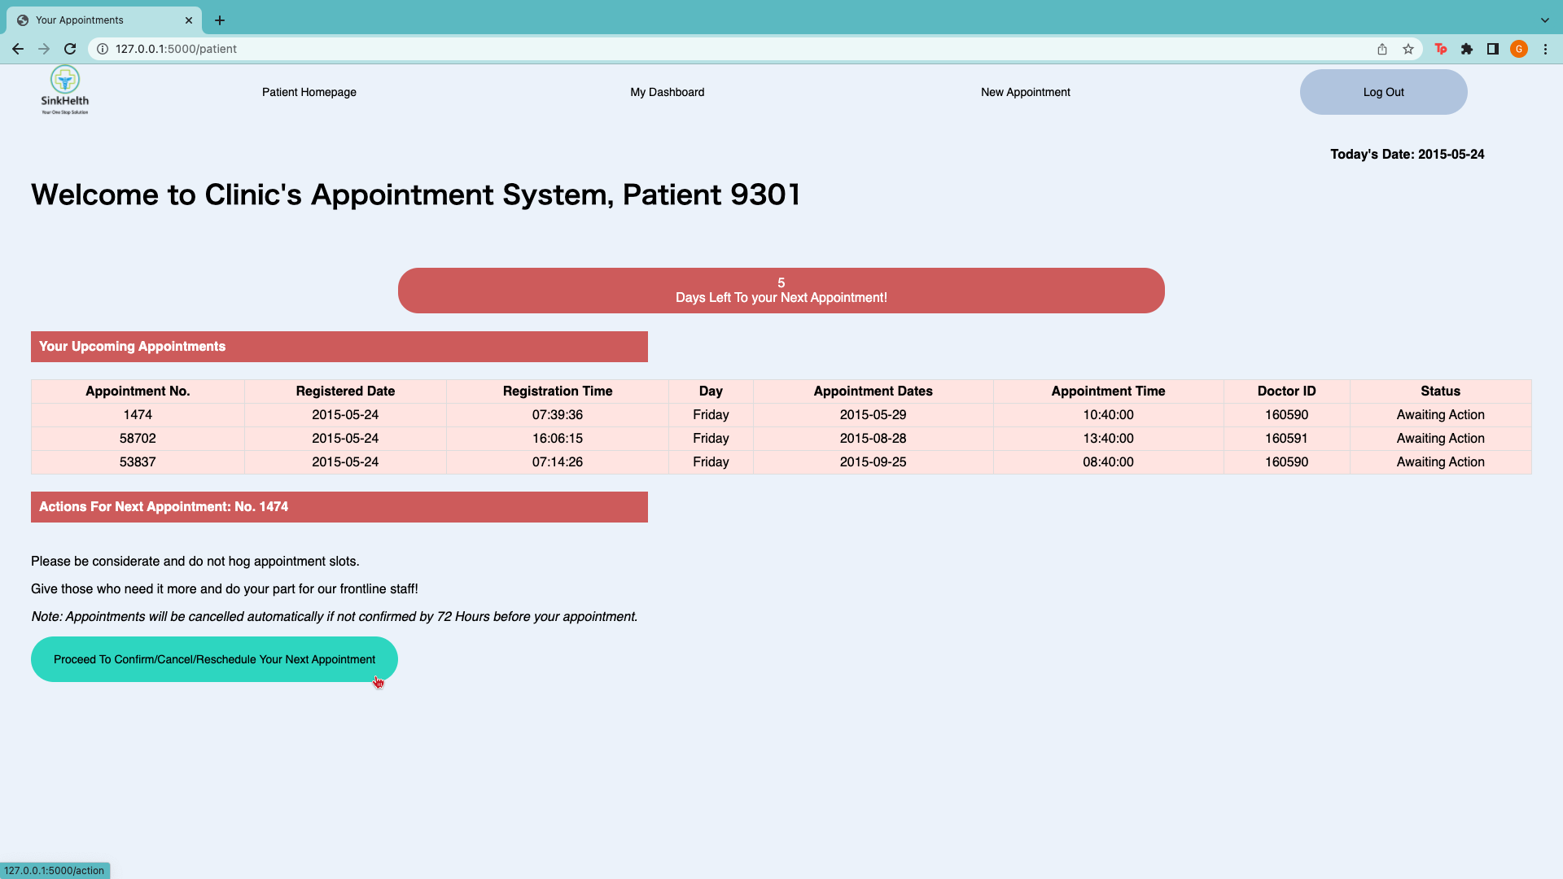

Click to Confirm/Cancel/Reschedule Upcoming Appointment

Action Required for Coming Appointment

Next Appointment In 5 Days Based on SMS Reminder

#### 8.2.2.1 Step 1.2a: To Act on the Upcoming Appointment:

To act on the upcoming appointment, user will be redirected to an action page to choose what to do with the upcoming appointment.

#### 8.2.2.2 Step 1.2b: Confirm/Cancel/Reschedule Appointment

The action page is where the user can select one of the three following buttons by hovering over the pictures.

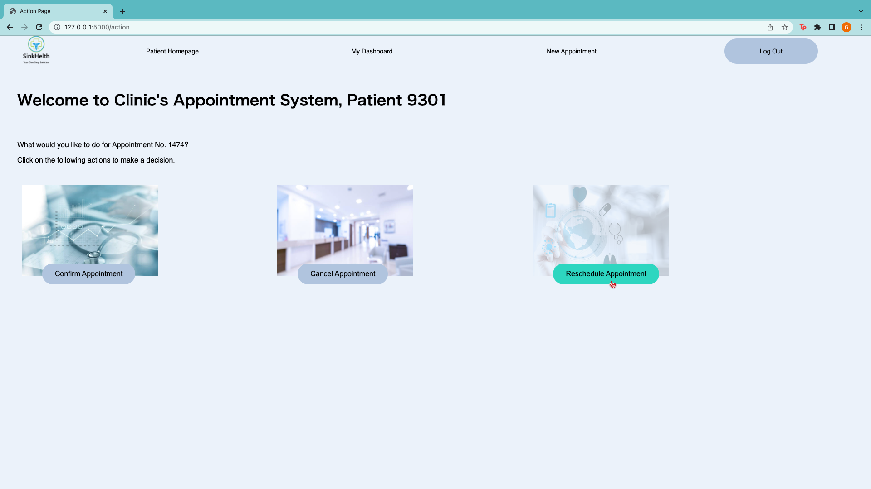

Select to Update Upcoming Appointment Status to prevent auto-cancellation and bad credit rating.

As all actions are irreversible, patients will be prompted to confirm their actions before redirecting to prevent unnecessary cancellation or confirmation of their appointments.

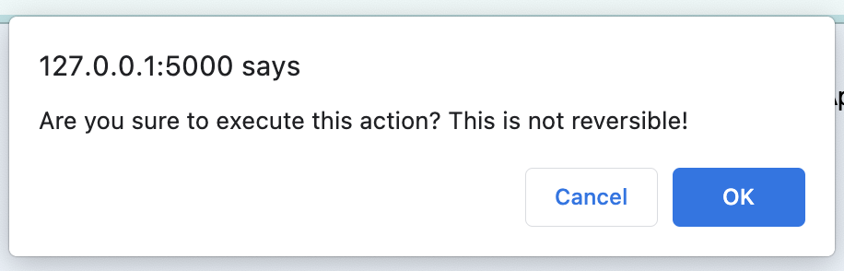

#### 8.2.2.3 Step 1.2c-1 Confirm Upcoming Appointment

When the patient confirms the upcoming appointment, the patient will be led to the confirmation page where the user will be assured that the appointment has been confirmed. The patient can then return to the main page to check their upcoming appointments to see that it has been confirmed and the actions required portion of the page will now be different as explained in scenario 2.

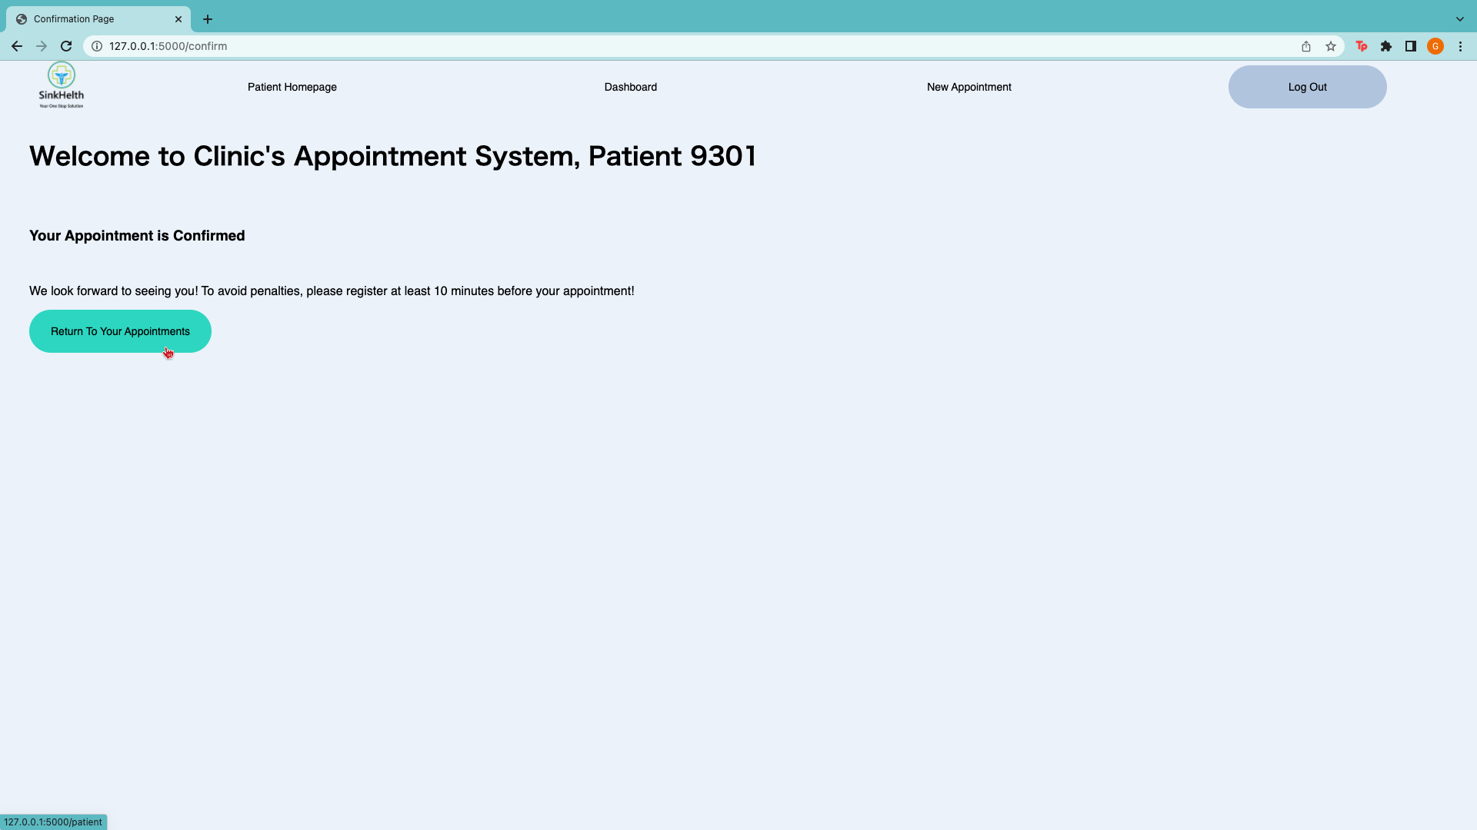

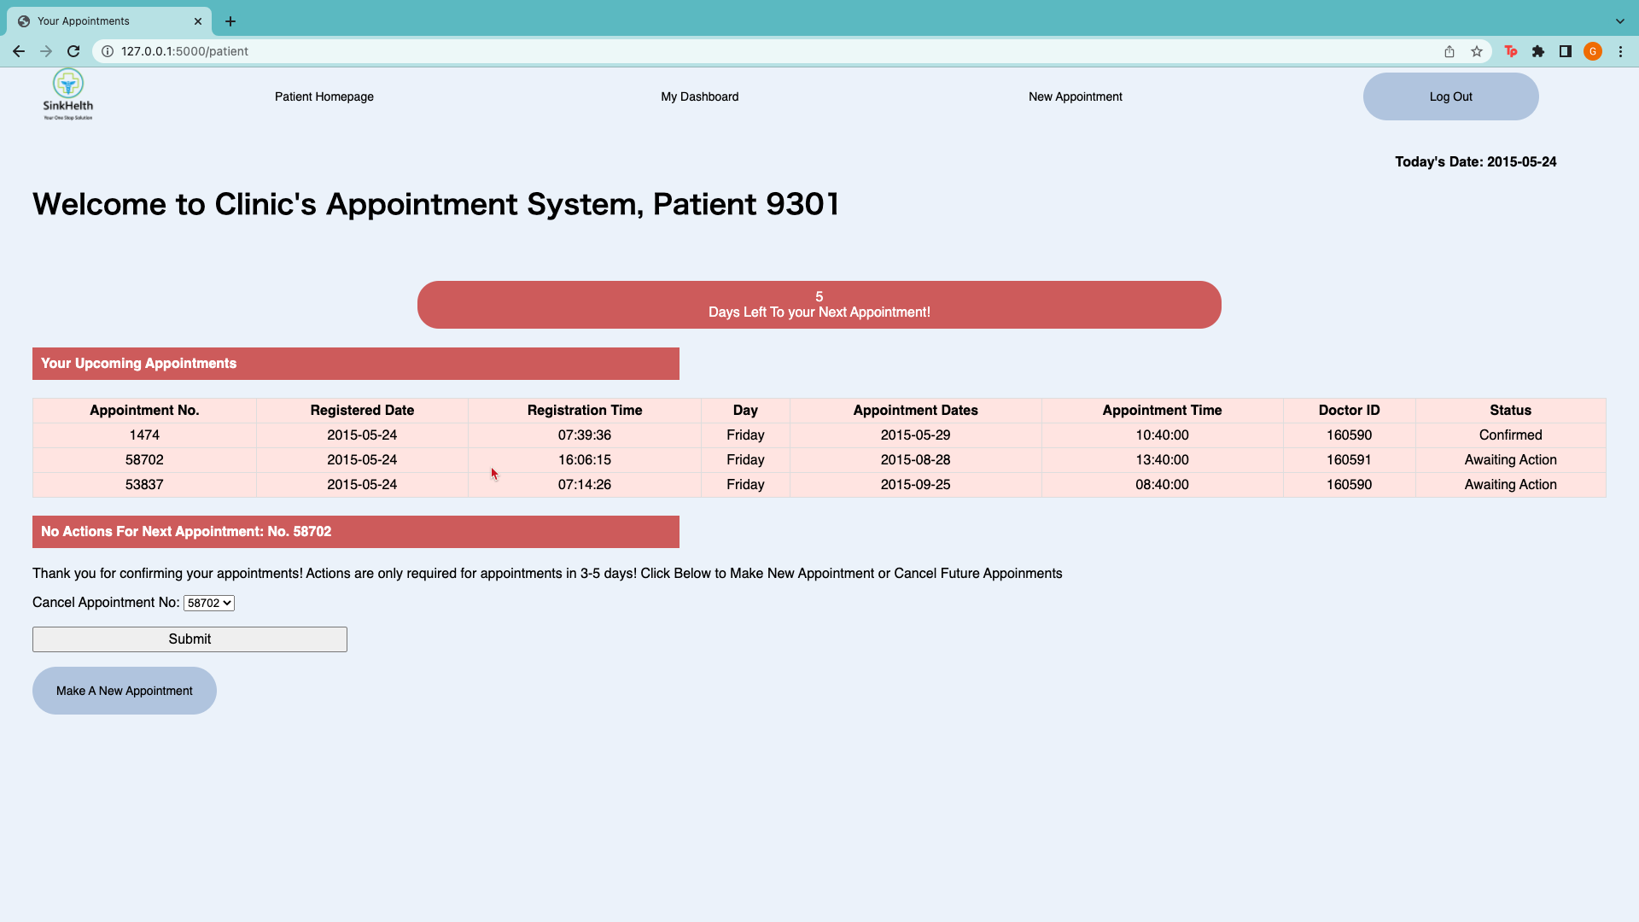

Actions No Longer Required after Appointment Confirmed

#### 8.2.2.4 Step 1.2c-2 Cancel Appointments

If the patient chooses to cancel the appointment, the patient will be redirected to the confirmation page and thereafter return to the appointment page. The appointment is now cancelled and is not shown on this page to minimise confusion for the patient but will remain in the database for recording purposes.

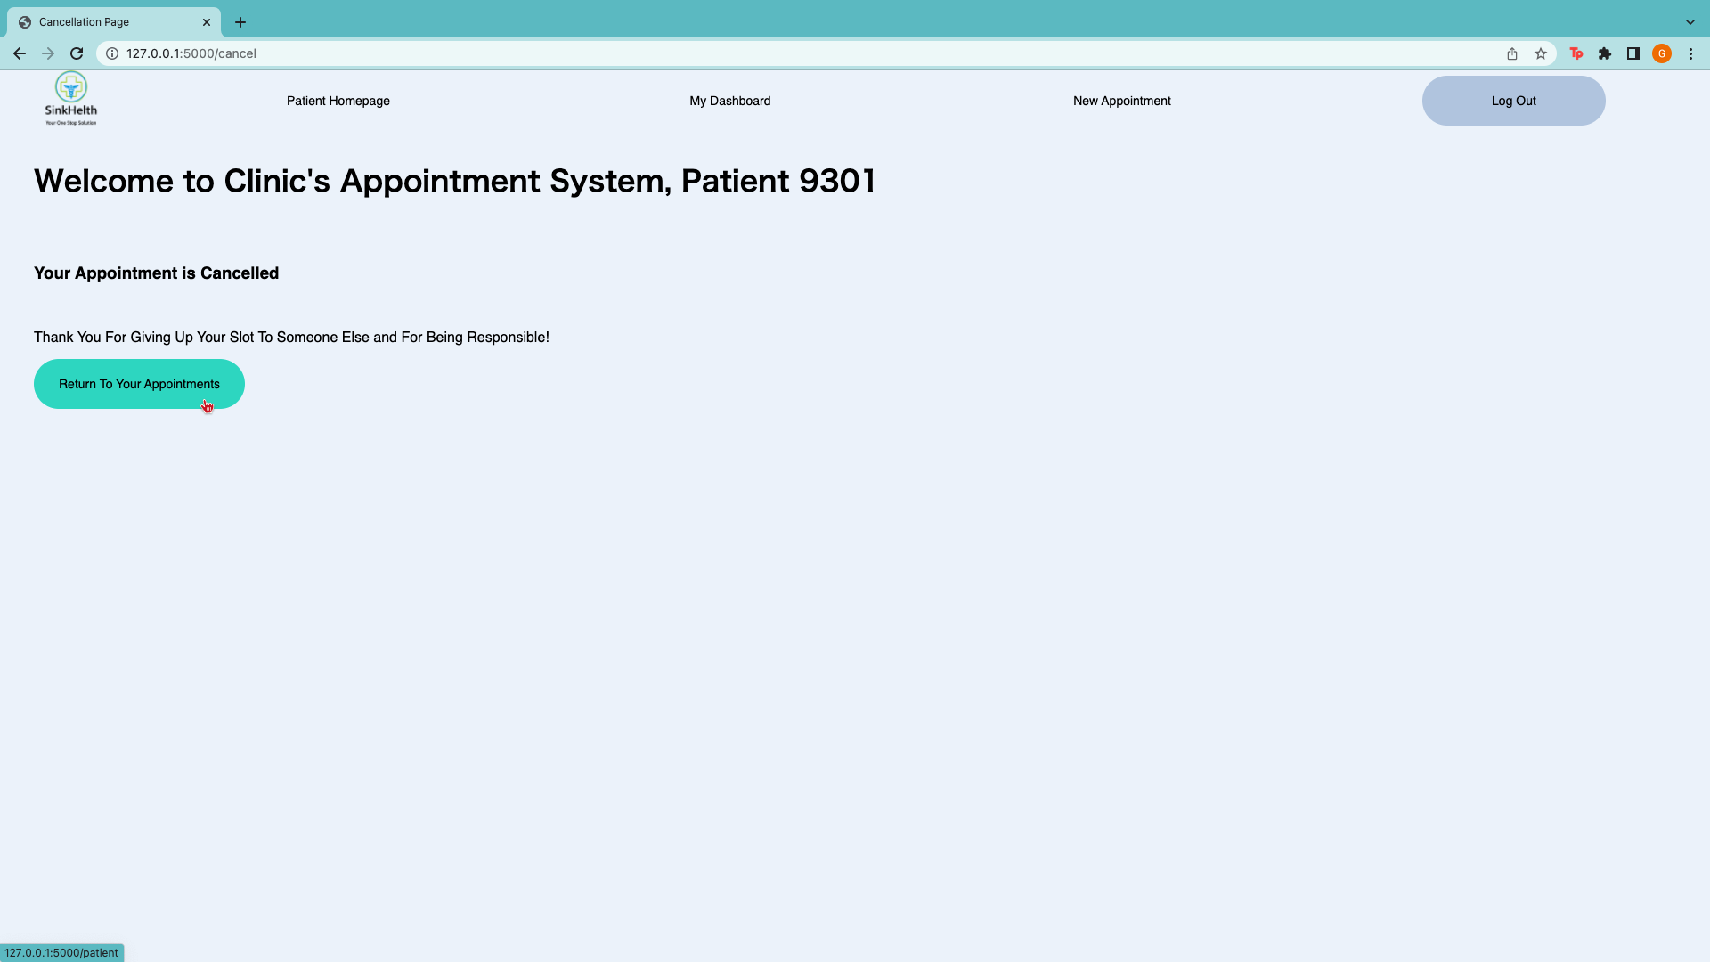

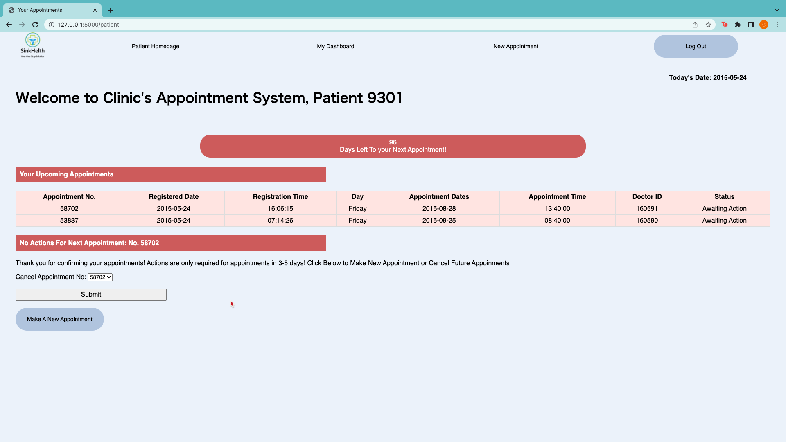

Cancelled Appointment Removed From Upcoming Appointments

Actions No Longer Required after appointment cancellation

#### 8.2.2.5 Step 1.2c-3 Reschedule Appointments

If the patient chooses to reschedule the appointment, the patient will be led to the rescheduling page where a list of available time slots after the 5th day will be displayed according to the clinic’s and doctors’ capacity.

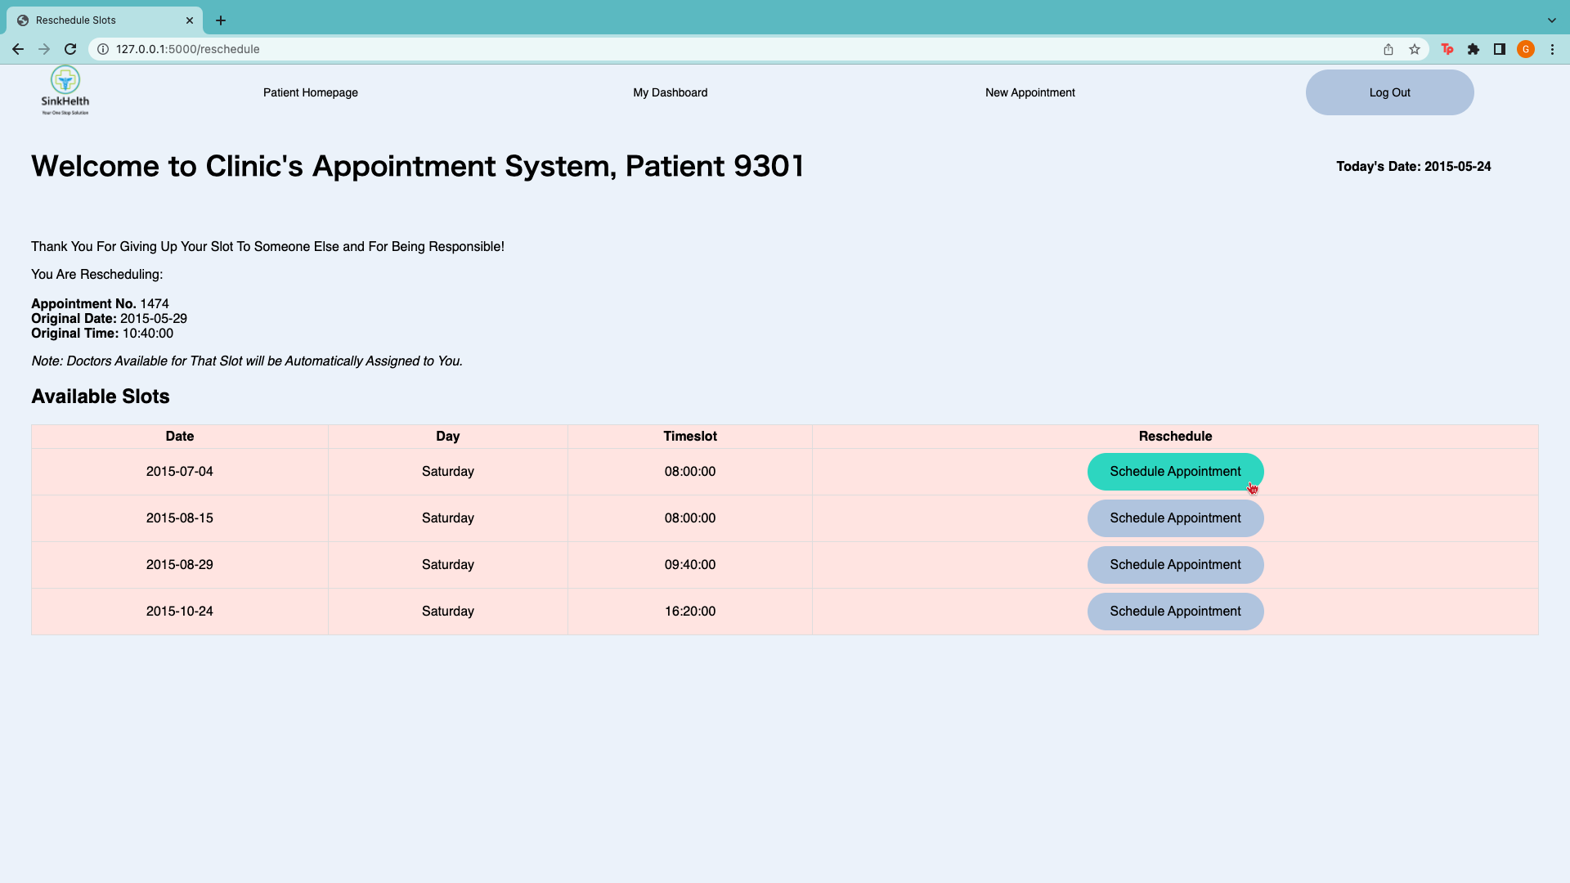

Information of Appointment You Are Rescheduling

Appointment Information

Click to Schedule Appointment

*Note: Doctors Will Automatically Be Assigned Based on Availability*

After choosing a slot, the patient will be led to a confirmation page for rescheduling. The patient can click on “Return to Appointment List” to check the rescheduled appointment.

For example, in this case the patient rescheduled it to the same date but a different time slot (09:40:00) and will require confirmation. If the rescheduled slot is more than 5 days, then no further action is required.

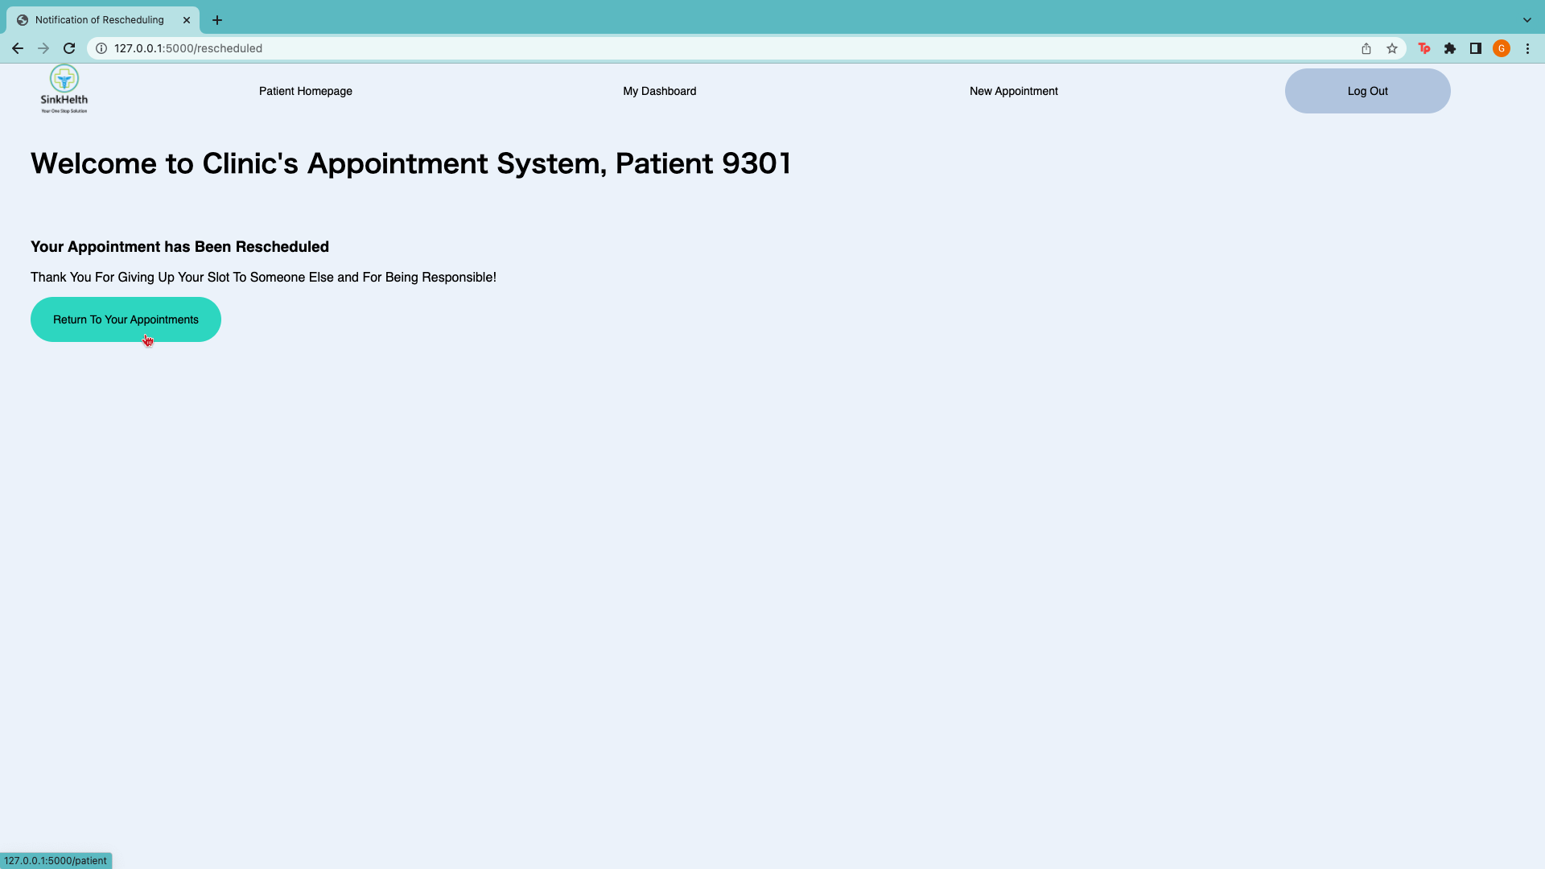

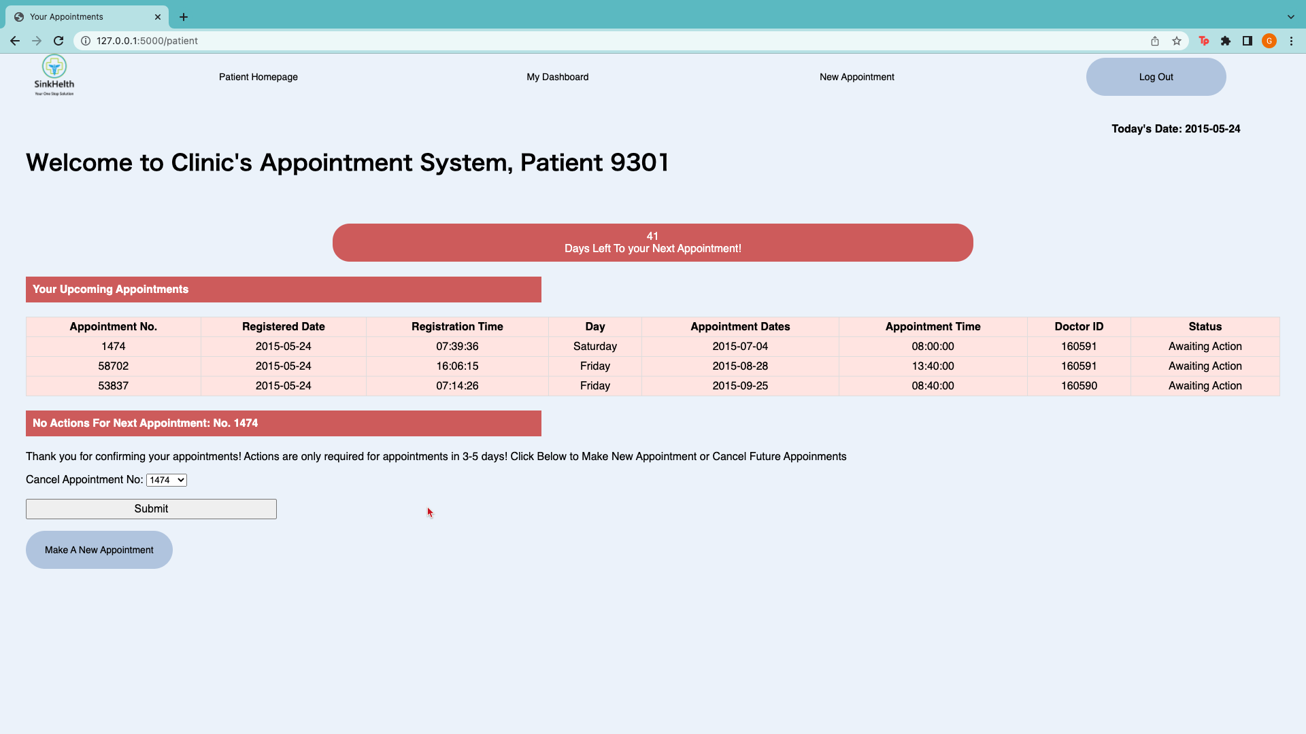

Check If Appointment Has Been Rescheduled

### 8.2.3 Scenario 3: No Upcoming Appointments

If the patient does not have any appointment, the following page will be shown.

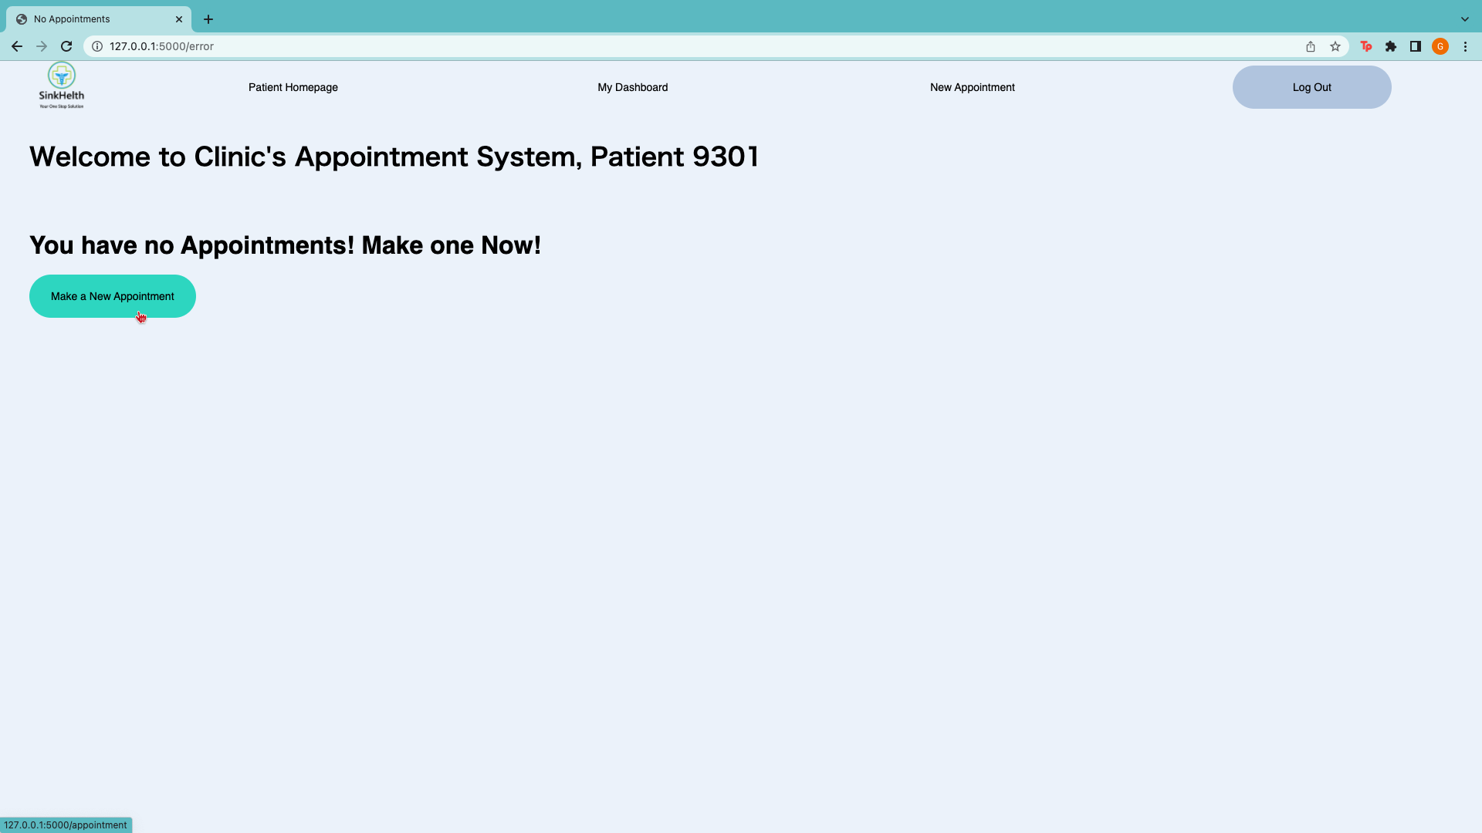

This is where patients can and are encouraged to book appointments which is done with the same steps as per “Step 1.1b”. Patients can also view their dashboard as per “Step 1.1c”.

Log Out

After the patient is done, the patient can log out of their session and their credentials will be removed from the system. After logging out, the patient will be led to the login page again to re-login or to leave the session.

## 8.3 Staff User Manual

After selecting “Employee Login” from the homepage, the staff will be led to our login page as follows. For demonstration purposes, Doctor ID: 160590, password: 160590 was used to login.

Login Page

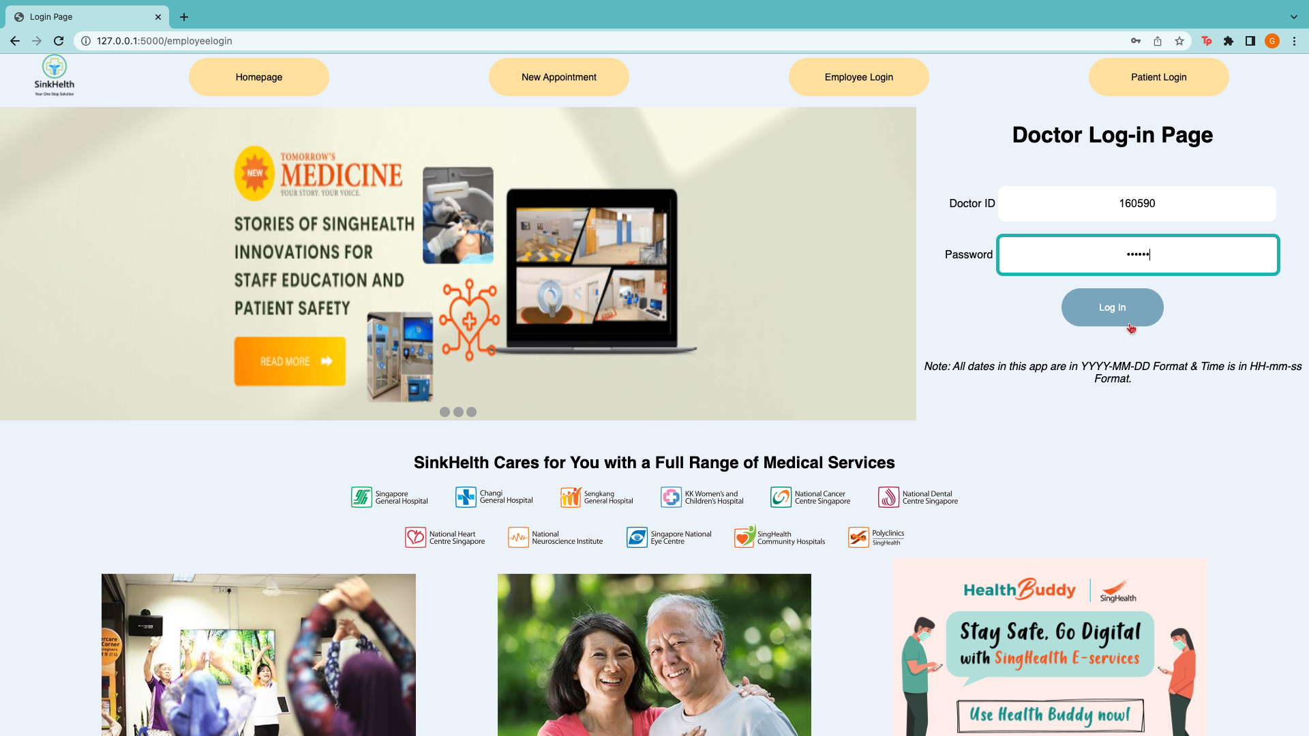

The staff can then enter their ID and password followed by pressing “Log In” or pressing Enter on their keyboard which will bring them to the homepage if the credentials are correct.

Staff Homepage

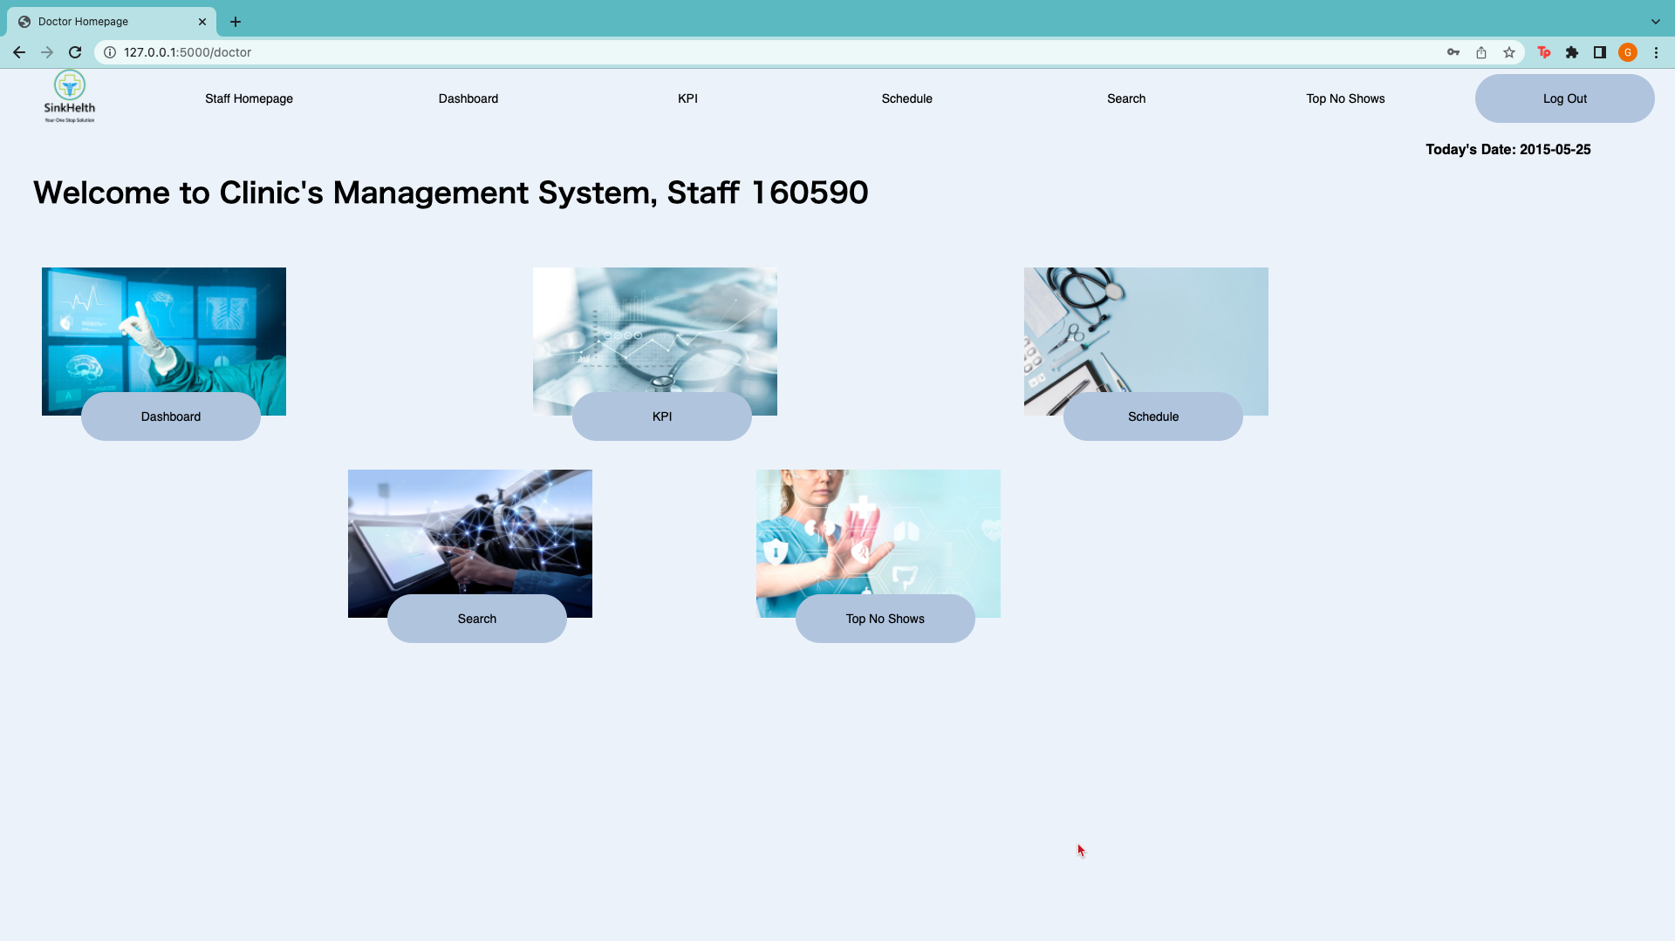

From the homepage, the staff can choose to access the various features by clicking on the word below the photo. A darker blue circle will appear when the staff hovers over the word.

Log Out

Staff can proceed to log out from the top menu bar once they are done with using the features. The log out will redirect them back to the home page.

### 

### 8.3.1 Feature 1: Dashboard

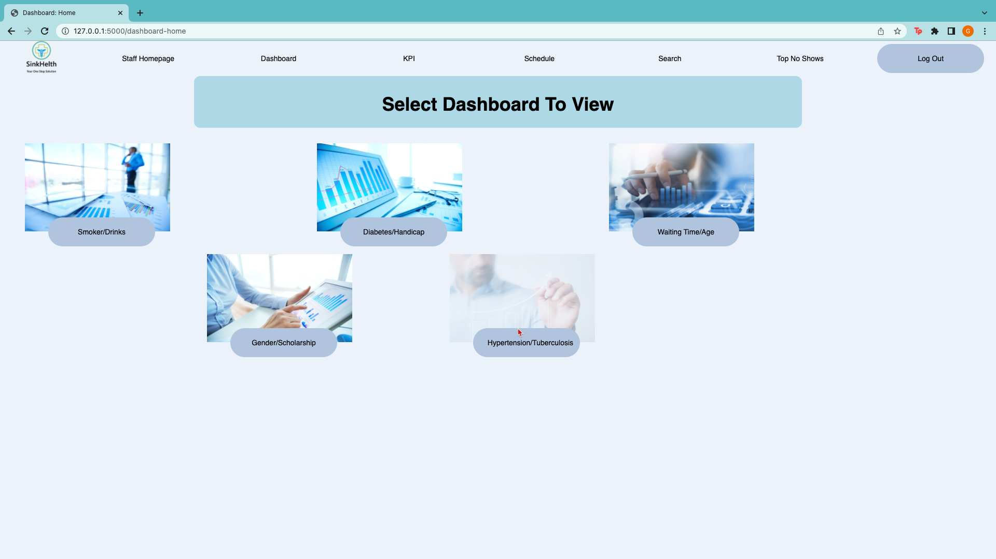

Upon clicking the dashboard feature, they will be led to the dashboard home page. From there, the staff can select the dashboard of the feature subset they want to view.

#### 8.3.1.1 Feature 1.1 Display of dashboards

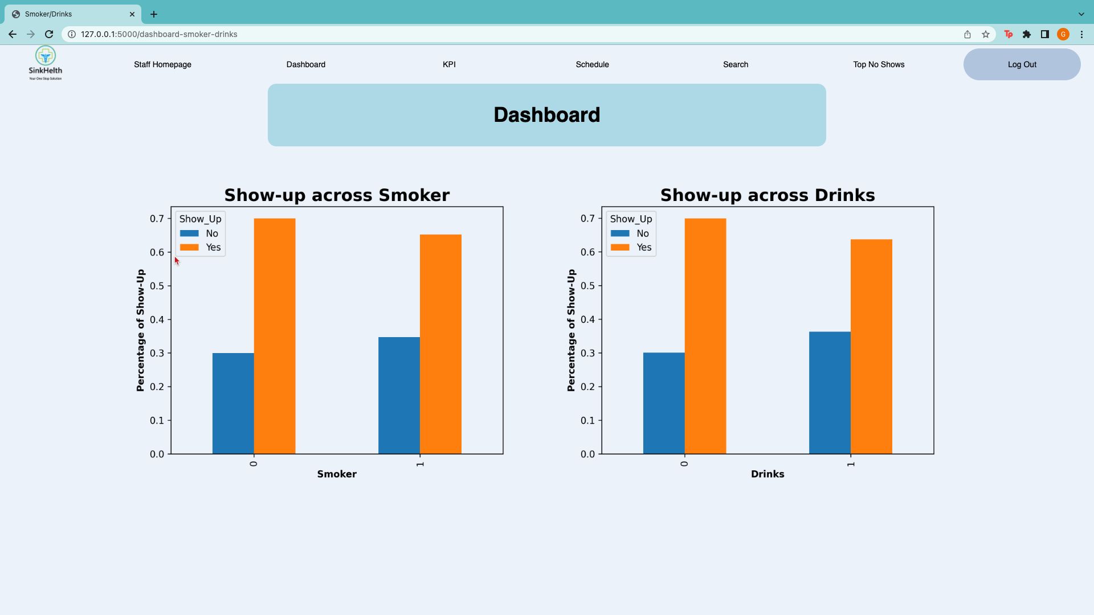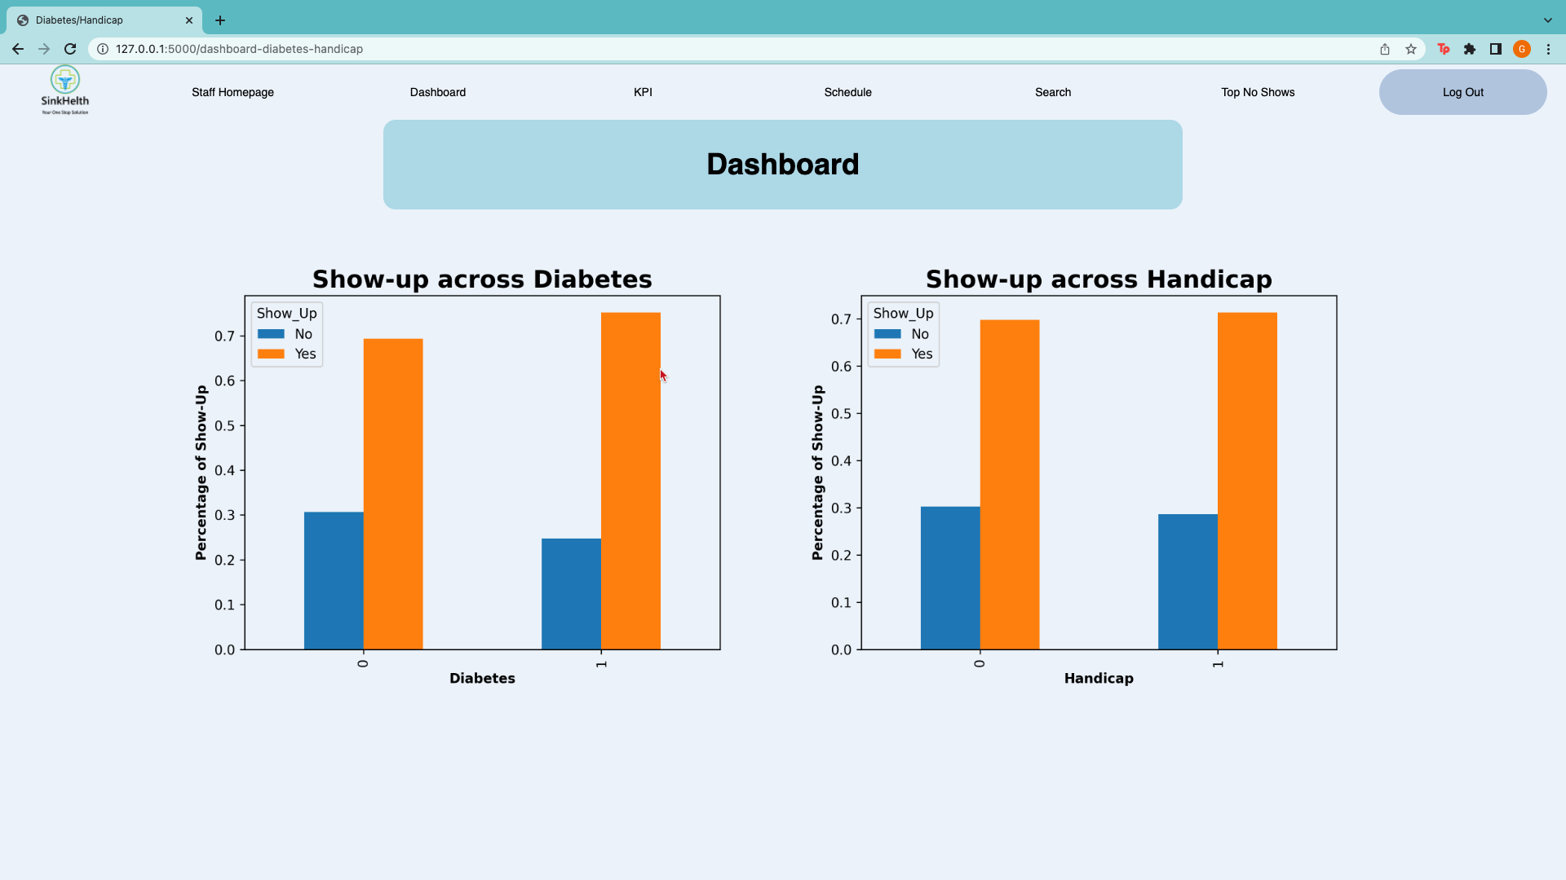

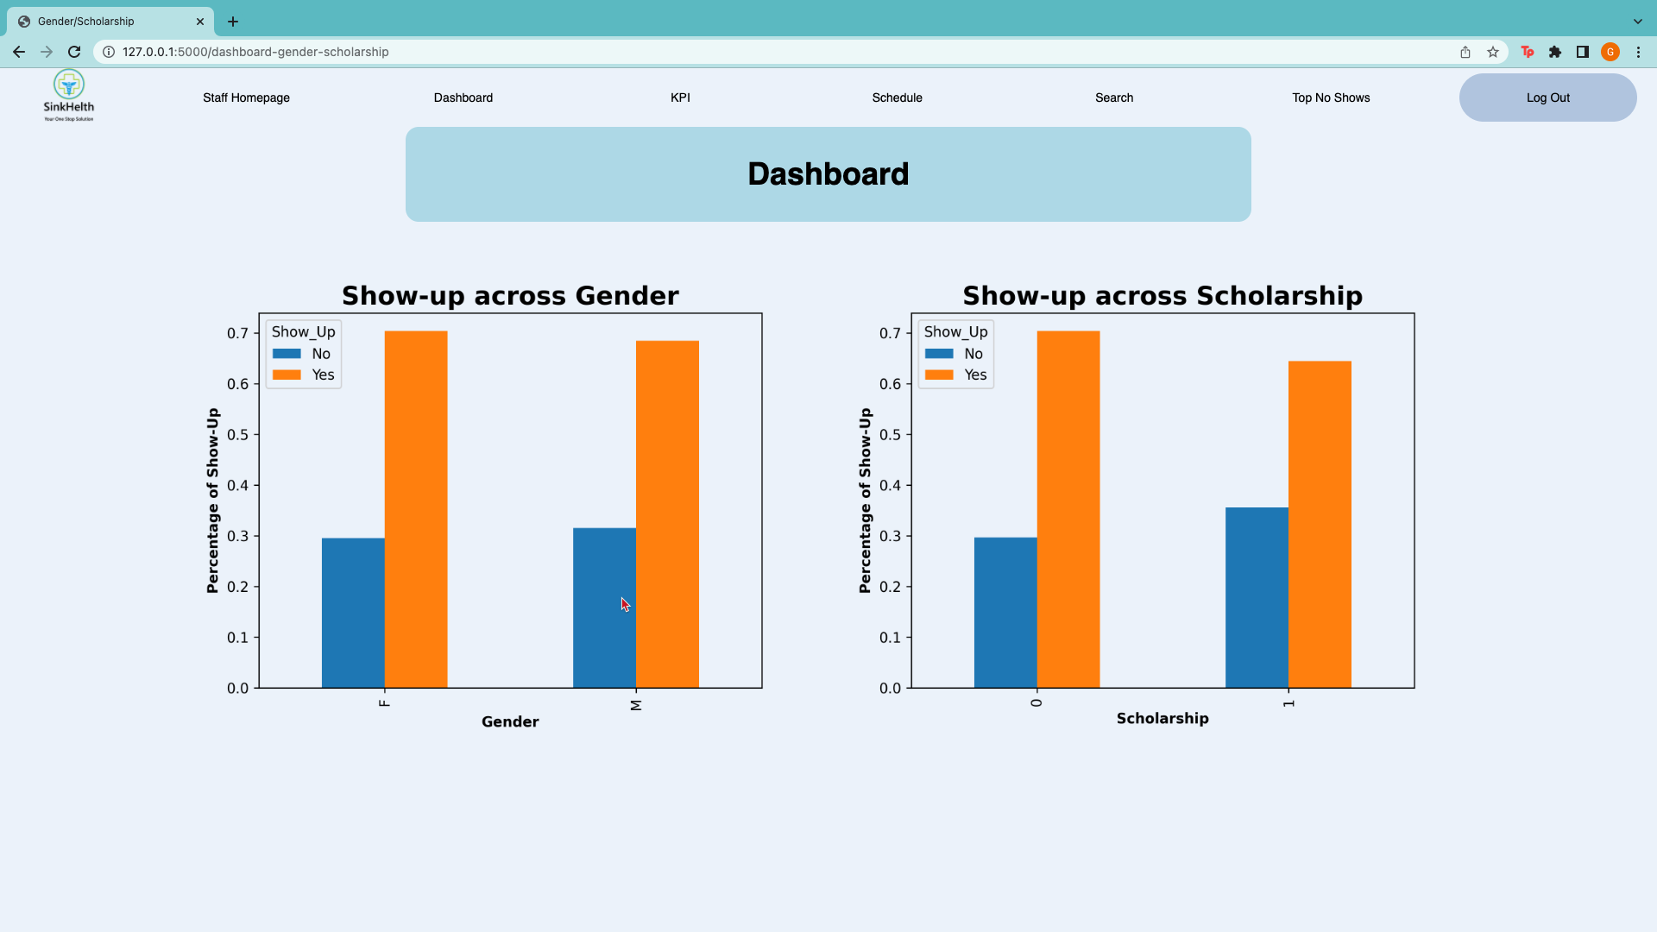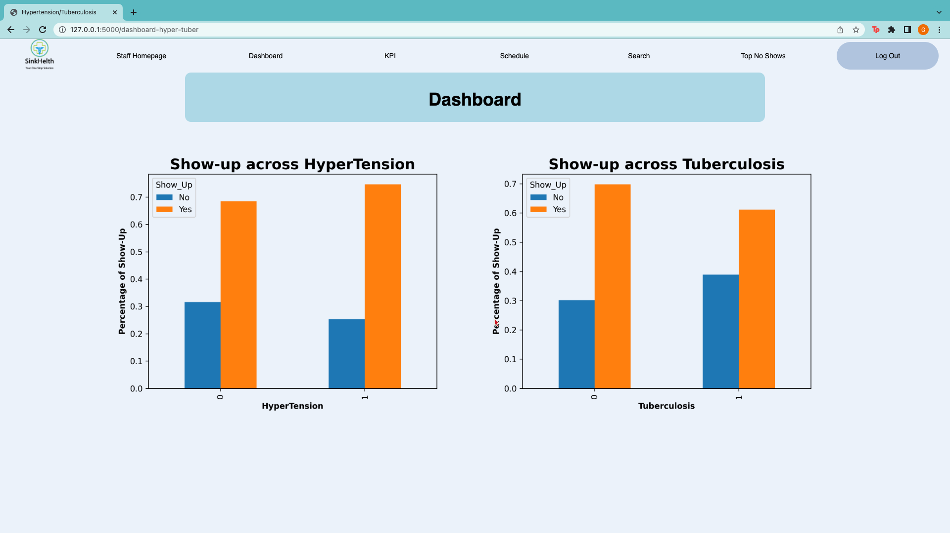

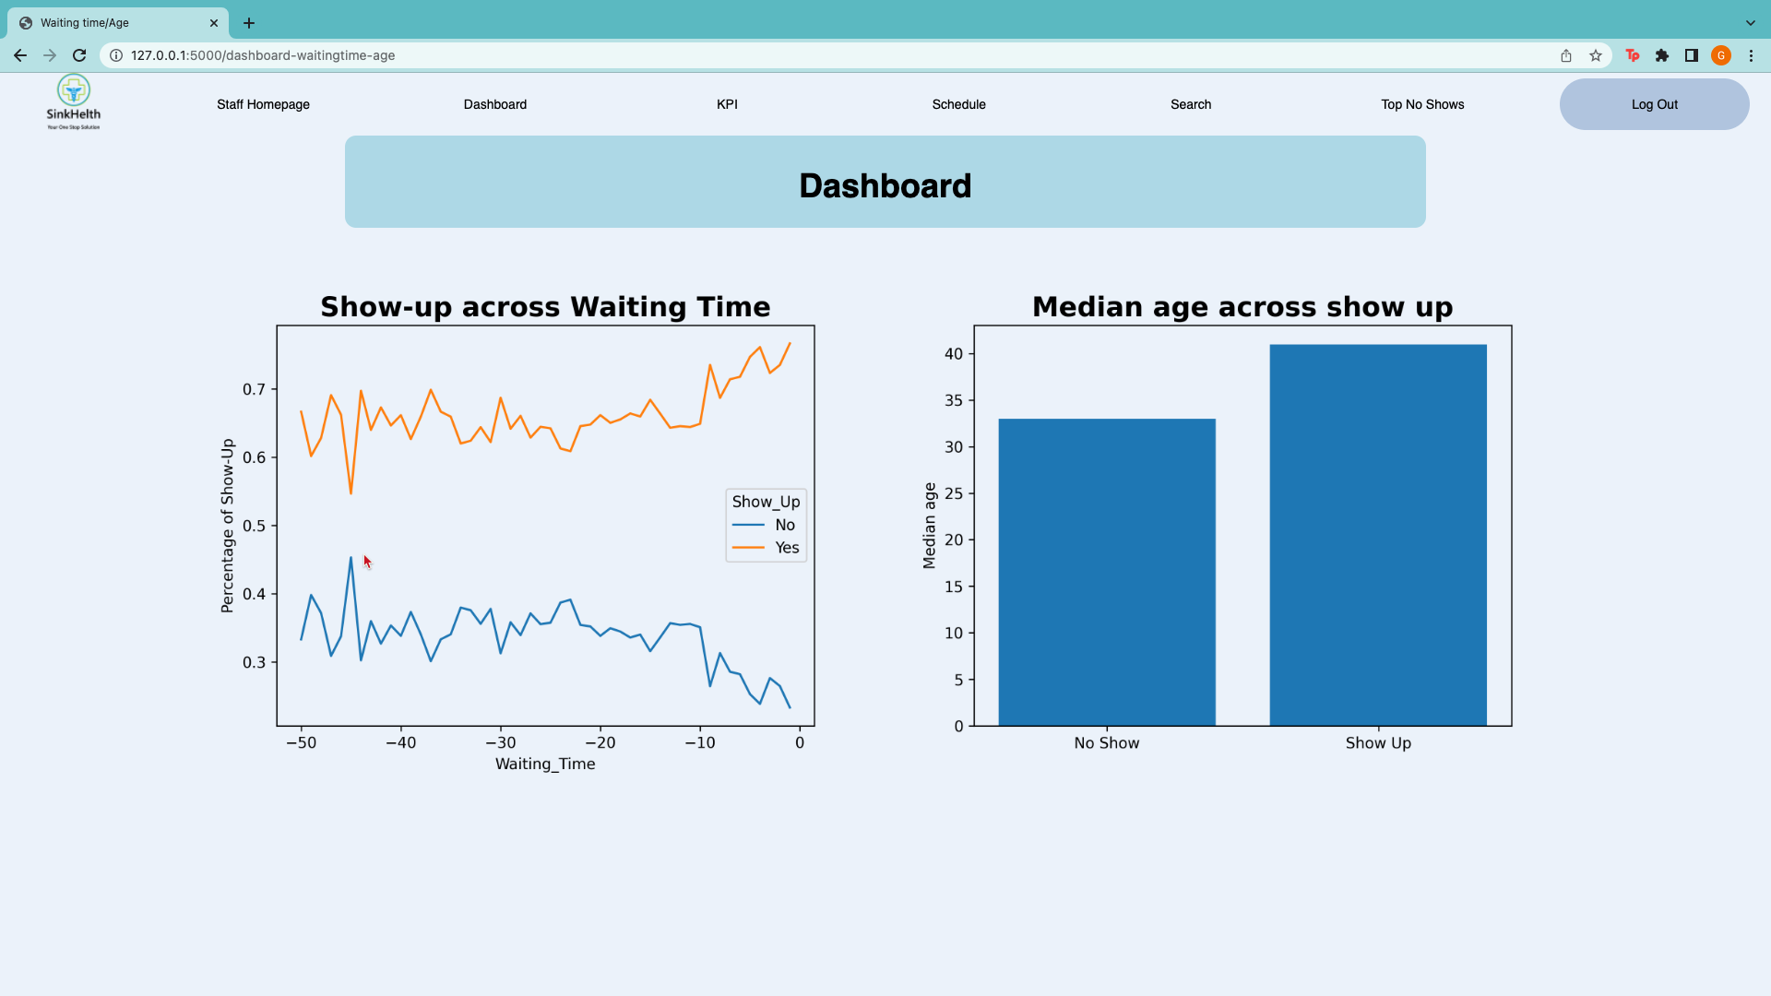

### 8.3.2 Feature 2: KPI

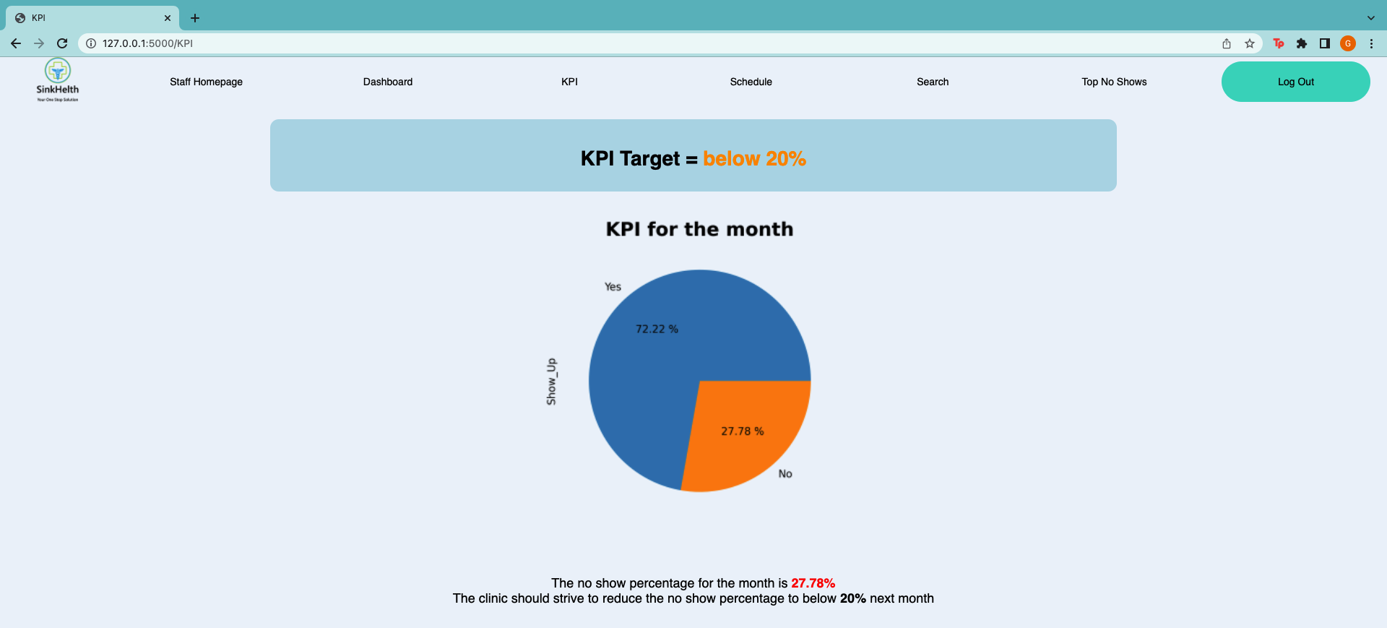

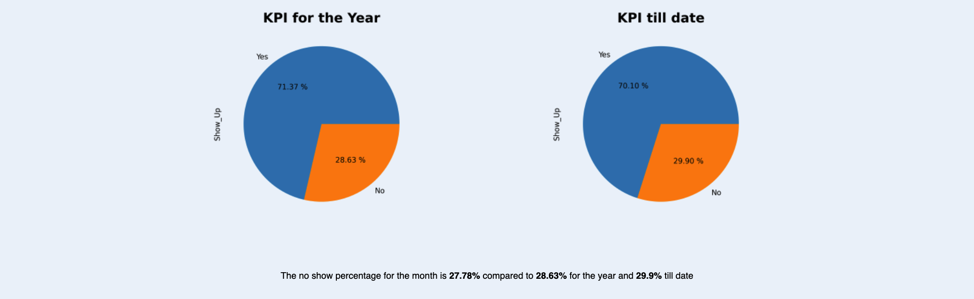

Staff will be redirected to the KPI page either through the homepage or from the top bar. The KPI target (less than 20%) is displayed at the top of the page. The staff can read the no show percentage for the month and if it is higher than the KPI target, the number will be red, and the website would remind the staff to strive to reduce the no show rates. If the monthly rate is lower than the KPI target, it will turn green, and the website would tell the staff to keep up the good work.

### 8.3.3 Feature 3: Search function

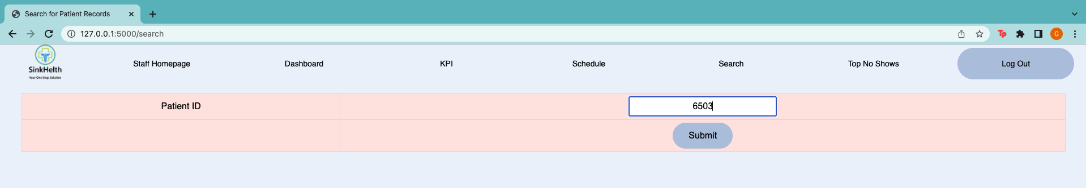

Upon choosing the search function from the homepage or top bar, the staff will be redirected to the search page. From there, the staff can input the patient id they hope to see and submit their request. This feature should be used in conjunction with the schedule and top no show features since the doctors will be able to have the patient id and then run it through the search to see their medical history as well as their past and future appointment records

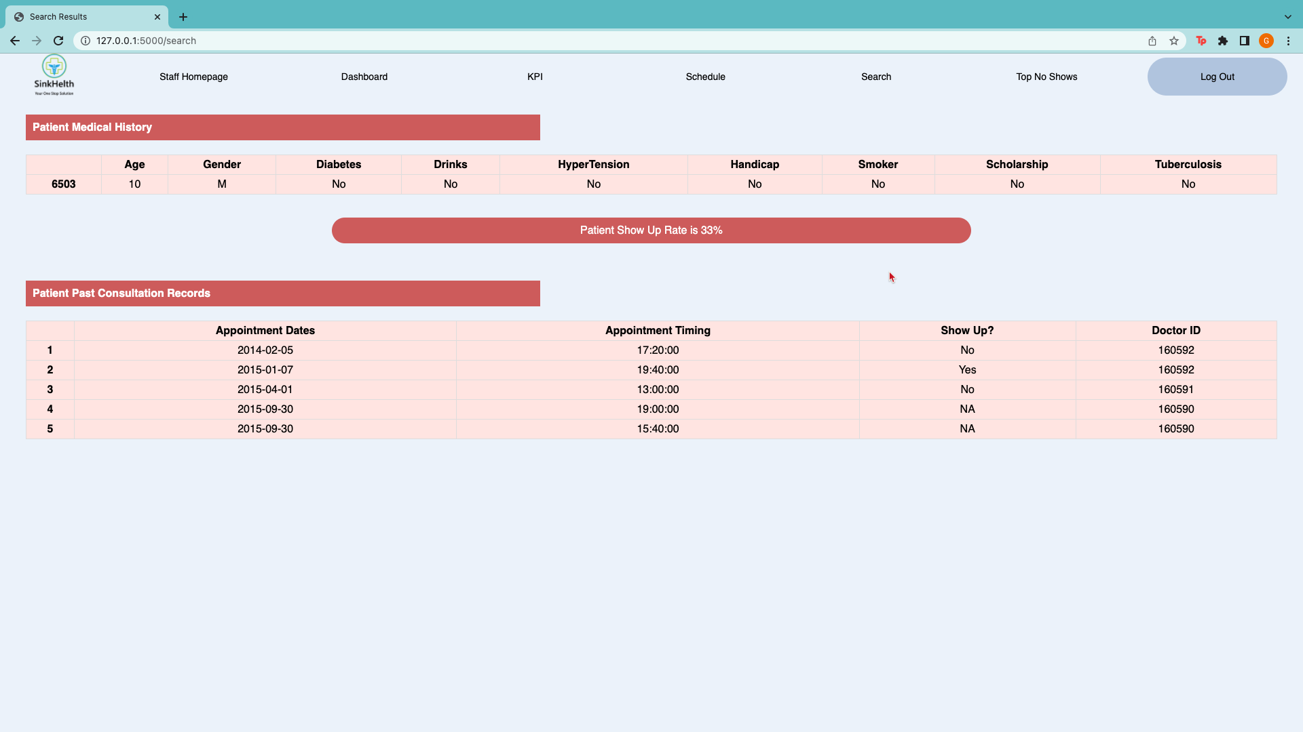

Once the staff has submitted their request, the patient record will be displayed. Details such as the no show rate, past records and medical history can be seen from the page.

### 8.3.4 Feature 4: Schedule

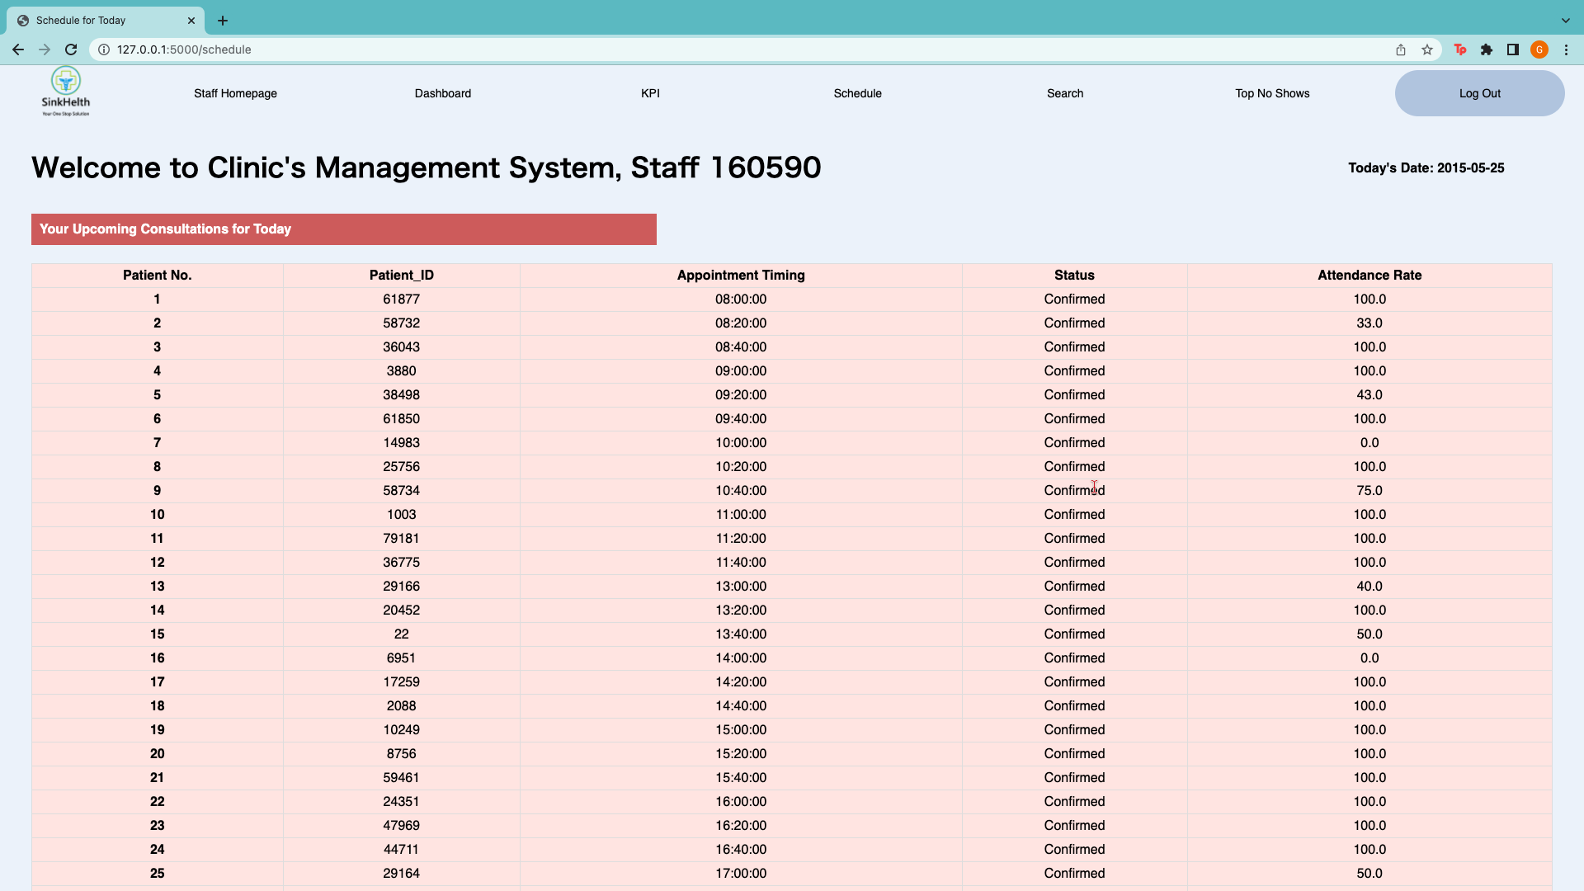

Upon pressing the Schedule function, the Doctor can view their consultations for the day. The list is sorted according to appointment time. The attendance rate and the status of their appointments are also displayed

### 8.3.5 Feature 5: Top No Show

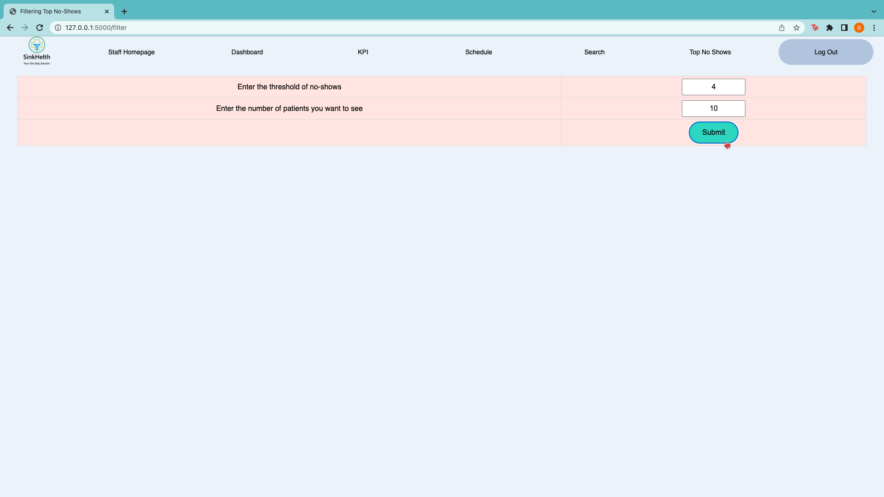

Upon choosing the Top No Show function, the staff can input the minimum threshold for no shows and the number of patients that they want to see.

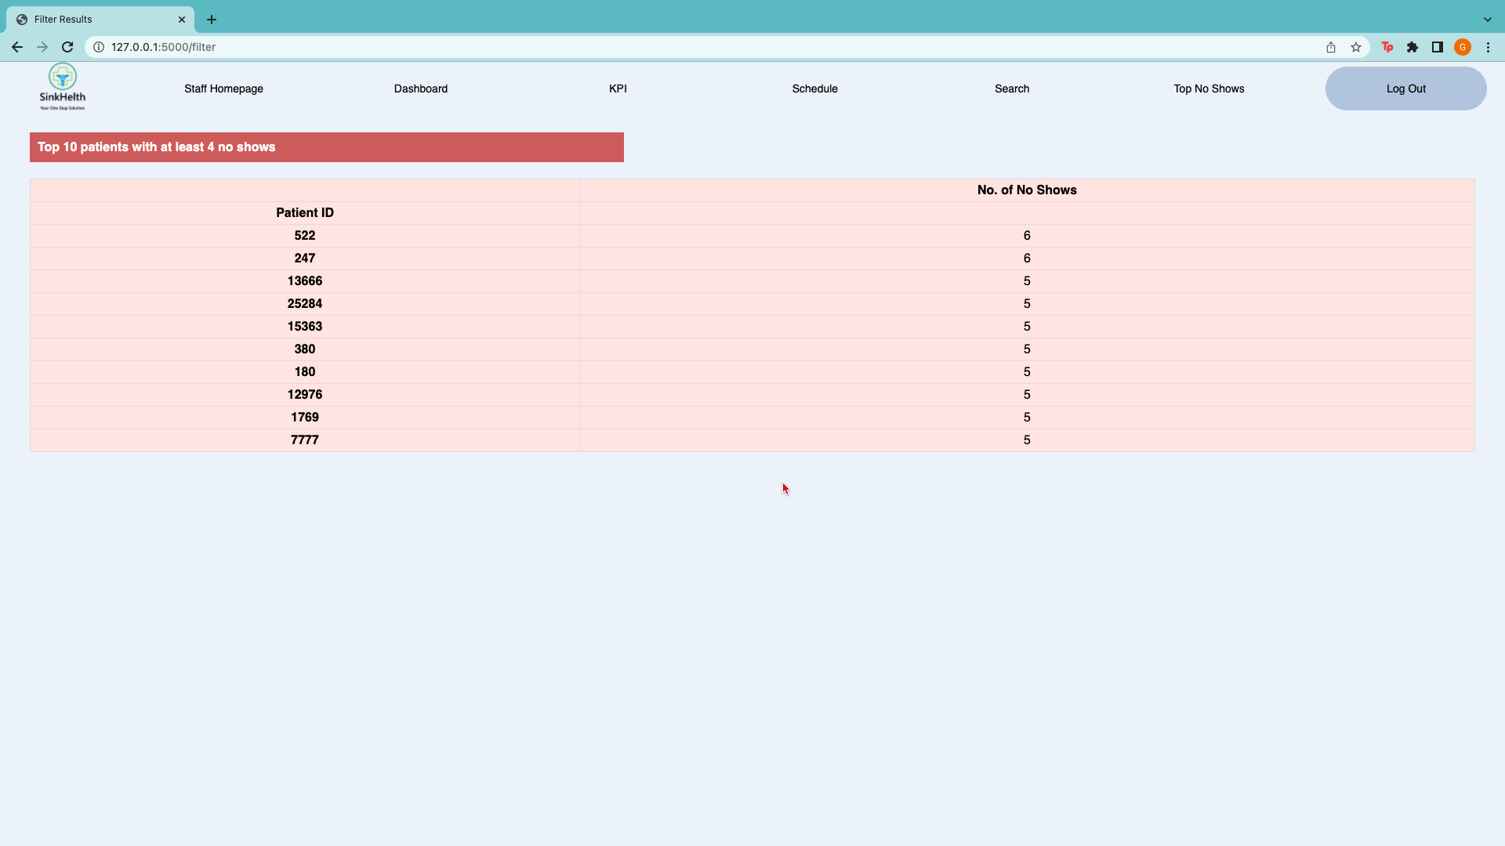

Once the staff has submitted their request, the list of patients will be shown and is sorted in descending order, according to the number of no shows used as a threshold earlier on.

# 9. Potential Future Expansion

As this webpage is still in its preliminary stages and much more work has to be done, our team hopes to put forward certain initiatives and features that could potentially be added to the existing webpage when more data is available, and more time is permitted.

## 9.1 Interactive Dashboard

The first potential future expansion would be to develop an interactive dashboard to enhance both user experience and allow the team to track, analyse, and display metrics of various sorts. The interactive dashboard would allow users to interact with the data, enabling them to make more well-informed and data-driven decisions.

The improved dashboard would display all metrics of various combinations on one single page, which would provide an overview of the data to users. Additionally, this interactive dashboard would allow users to zoom in and focus on data they desire just by hovering on the dashboard itself without having to click into another landing page. The improved dashboard will further enable interactivity through a click-to-filter option which allows users to filter the data based on what they are searching for, and it will automatically be reflected in the dashboard.

By implementing such a dashboard, it will help simplify the working environment and analysis processes since there are massive volumes of data collected on a daily level.

## 9.2 Predictive Dashboard

The second potential future expansion would be to implement predictive analytics to the dashboards. This would include extracting information from data and using it to predict trends and behaviour patterns which would help the business to plan their resources better in the future.

Through predictive analytics, employees would be able to predict the no show rate of patients which would help facilitate the advanced planning and allocation of sufficient resources. By analysing historical data from patients who made their appointments, patients who missed them, and patients who rescheduled, predictive analytics applications can find common factors and correlations in patients who often miss appointments.

This would help decrease the workload for employees as well as provide them an insight into the key factors that affect no show rate on a moving basis. It can also help recommend actions that employees can take to reduce the number of missed appointments

## 9.3 Prioritisation and Waitlists

Another potential future expansion would be to provide for prioritisation of appointments as well as waitlists. Patients' appointments can vary in urgency according to multiple factors. Hence, the updated system would allow patients to describe their situation, if any, and tell employees about the frequency and intensity and symptoms. This will allow employees to make the final decision if any patients require urgent consultation with a specific specialist and if necessary, additional information and rearrangement of appointments can be carried out.

Secondly, the virtual waitlist system would help mitigate the risk of cancelled appointments. It would allow patients to waitlist for a slot if it is fully booked and if there is an opening in the next few days, the system would send the patient a notification to choose if they would like to bring forward their consultation. All of which would be done through the appointment system.

# 

# 10. Work Distribution

|  |  |
| --- | --- |
| **Sections** | **Work Allocation** |
| Cleaning & Exploration | Galvin, Feng Yuan, Jing Yee, Xavier, Kerryn |
| Homepage | Kerryn |
| Patient Features | Jing Yee, Galvin |
| Staff Features | Xavier, Feng Yuan |
| Report | Feng Yuan, Galvin, Kerryn, Jing Yee, Xavier |
| SMS Reminder System | Kerryn, Xavier |

# 

# 11. References

Barron WM. Failed appointments. Who misses them, why they are missed, and what can be done. Primary Care. 1980 Dec;7(4):563-574. PMID: 7010402.

Bleustein, C., Rothschild, D. B., Valen, A., Valatis, E., Schweitzer, L., & Jones, R. (2014). Wait times, patient satisfaction scores, and the perception of care. The American journal of managed care, 20(5), 393–400.

Berdah, B. (2018). Create a simple SMS delivery notification system (Python). Callr.com. Retrieved 15 April 2022, from https://www.callr.com/blog/sms-delivery-notification-system/.

Caputo, J. M., Smigelski, M., Sebesta, E. M., Li, G., Rutman, M. P., & Cooper, K. L. (2020). Increased time between scheduling date and appointment date results in increased no-show rates in the academic urology practice. Urology Practice, 7(6), 461–466. https://doi.org/10.1097/upj.0000000000000147

Impact of covid-19 on Singapore's healthcare industry. RSM Singapore. (2021, June). Retrieved April 15, 2022, from https://www.rsm.global/singapore/insights/our-expert-insights/impact-covid-19-singapores-healthcare-industry

Lacy, N. L. (2004). Why we don't come: Patient perceptions on no-shows. The Annals of Family Medicine, 2(6), 541–545. https://doi.org/10.1370/afm.123

Liu, J., Xie, J., Yang, K., & Zheng, Z. (2019). Effects of Rescheduling on Patient No-Show Behavior in Outpatient Clinics. Manufacturing &Amp; Service Operations Management, 21(4), 780-797. https://doi.org/10.1287/msom.2018.0724

Marbouh, D., Khaleel, I., Al Shanqiti, K., Al Tamimi, M., Simsekler, M., & Ellahham, S. et al. (2020). &lt;p&gt;Evaluating the Impact of Patient No-Shows on Service Quality&lt;/p&gt;. Risk Management And Healthcare Policy, Volume 13, 509-517. https://doi.org/10.2147/rmhp.s232114

Mastros, G. (2009). LessThanDot - Do not use spaces or other invalid characters in your column names. LessThanDot. Retrieved 15 April 2022, from <https://blogs.lessthandot.com/index.php/datamgmt/dbprogramming/do-not-use-spaces-or-other-invalid-chara/#:~:text=Column%20names%20>

Moore, Charity G, Patricia Wilson-Witherspoon, Janice C Probst. 2001. Time and money: Effects of noshows at a family practice residency clinic. Family Medicine 33(7) 522–527.

Pesata, Virginia, Geri Pallija, Adele A Webb. (1999). A descriptive study of missed appointments: Families’ perceptions of barriers to care. Journal of Paediatric Health Care

The impact of covid-19 on Health and Health Systems. OECD. (n.d.). Retrieved April 15, 2022, from https://www.oecd.org/health/covid-19.htm

UN. (1982). Provisional Guidelines on Standard International Age Classification. Unstats.un.org. Retrieved 15 April 2022, from <https://unstats.un.org/unsd/publication/SeriesM/SeriesM_74e.pdf>

Well. (2022). 8 Ways to Reduce Patient No-Show Rates | WELL Health. WELL Health. Retrieved 15 April 2022, from <https://wellapp.com/blog/patient-no-show-rates/>.